**RAJALAKSHMI ENGINEERING COLLEGERAJALAKSHMINAGAR,THANDALAM– 602 105**

CS23332DATABASEMANAGEMENT

SYSTEMSLAB

**Laboratory Record Notebook**

Name:

**DEVESH.D**

Year / Branch / Section:

**2nd year / B.Tech -AIML/ A**

UniversityRegisterNo:

**2116231501034**

CollegeRollNo:

**231501034**

Semester:

**3rd Semester**

AcademicYear:

**2023 - 2024**

**CS23332DATABASEMANAGEMENTSYSTEMS**

|  |  |
| --- | --- |
| **NAME** | **DEVESH D** |
| **ROLL NO.** | **2116231501034** |
| **DEPT** | **AIML** |
| **SEC** | **‘A’** |

|  |  |  |
| --- | --- | --- |
| **Ex.No.: 1** | | **CREATIONOFBASETABLEAND**  **DML OPERATIONS** |
| **Date:** | 01/08/2024 |

1. CreateMY_EMPLOYEEtablewiththefollowingstructure

CREATE TABLE MY_EMPLOYEE(IDNumber(4)NOTNULL,

Last_name Varchar(25),First_name Varchar(25),Userid Varchar(25),SalaryNumber(9,2)

);

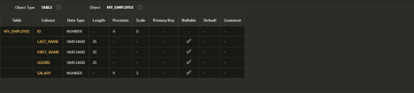

1. AddthefirstrowandsecondrowsdatatoMY_EMPLOYEEtablefromthesampletable

Insert intoMY_EMPLOYEE(&ID,&LAST_NAME,&FIRST_NAME,&USERID,&SALARY

)

values(1,”Patel”,”Ralph”,”rpatel”,8952,”Dancs”,”Betty”,”bdancs”,860);

1. Display the table with values

Select*fromMY_EMPLOYEE;

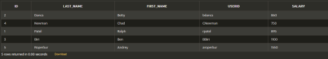

1. populate the next two rows of data from the sample data. Concatenatethefirstletterofthefirst_NAMEwithfirstsevenlettersofthelast_nametoproduceUserid

UpdateMY_EMPLOYEES

SetUserid=substr(first_name,1,1)||substr(last_name,1,7)WhereIDin(3,4);

1. deleteBettydancsfrommy_employeetable`1DeletefromMY_EMPLOYEE

WhereFIRST_NAME=‘Betty’andLAST_NAME=‘Dancs’;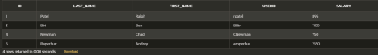

1. EmptythefourthrowoftheemptableDeletefromMY_EMPLOYEE

WhereID=5;



1. MakethedataadditionspermanentCommit;
2. Changethelastnameofemployee3toDrexler

UpdateMY_EMPLOYEESet LAST_NAME = “Drexler”WhereID=3;



1. Changethesalaryto1000foralltheemployeeswithasalarylessthan900.

Update MY_EMPLOYEESetsalary=1000

Wheresalary<900;



|  |  |  |
| --- | --- | --- |
| **Ex.No.: 2** | | **DATA MANIPULATIONS** |
| **Date:** | 08/08/2024 |

1. Findouttheemployeeid,names,salariesofalltheemployeesselectEmployee_id,First_Name,SalaryfromEMPLOYEES;

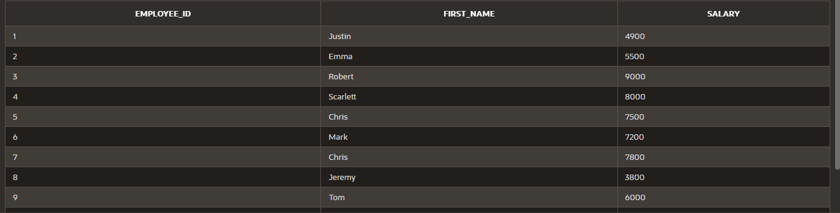

1. Listouttheemployeeswhoworksundermanager100

selectFirst_Name||''||Last_NameasnamefromEMPLOYEESwheremanager_id

=100;

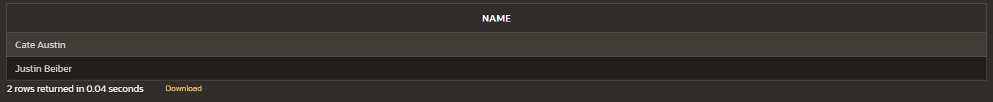

1. Findthenamesoftheemployeeswhohaveasalarygreaterthanorequalto4800

selectFirst_Name ||''||Last_NameasnamefromEMPLOYEES

Wheresalary>=4800;

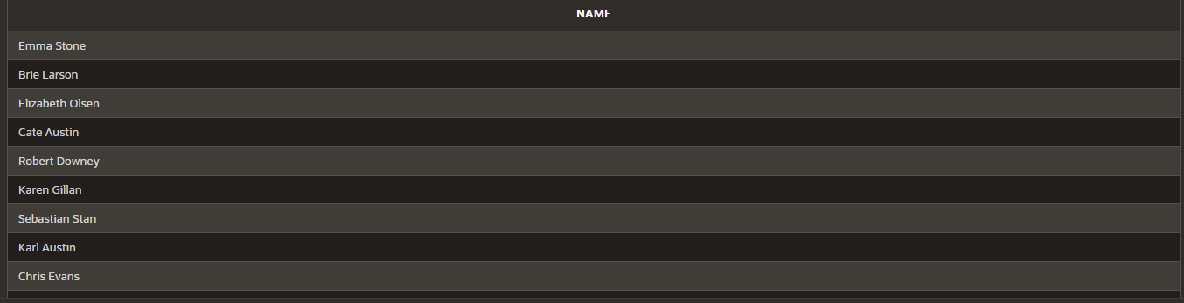

1. List out theemployeeswhose last nameis ̳AUSTIN

selectFirst_Name||''||Last_NameasnamefromEMPLOYEES

whereLast_Name='Austin';

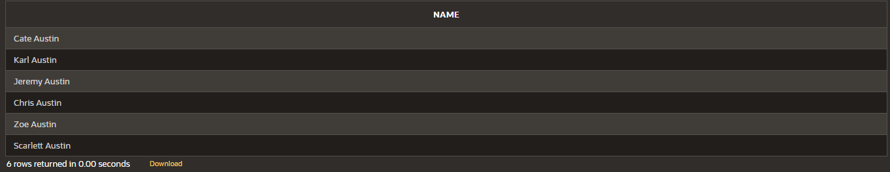

1. Findthenamesoftheemployeeswhoworksindepartments60,70and80

selectFirst_Name||''||Last_NameasnamefromEMPLOYEES

whereDepartment_idin(60,70,80);

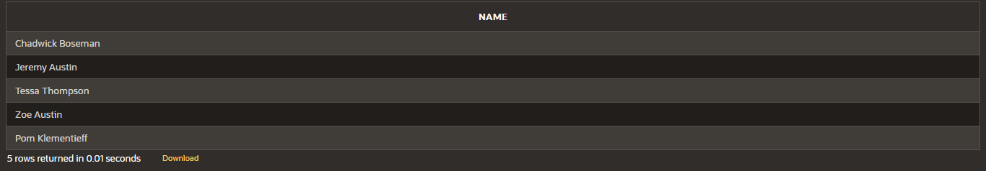

1. DisplaytheuniqueManager_Id.

selectDISTINCT(manager_id)fromEMPLOYEES;



1. InsertFiveRecordsandcalculateGrossPayandNetPay.

INSERTINTOEmp(EmpNo,EmpName,Job,Basic,DA,HRA,PF,GrossPay,NetPay)VALUES(

101,'JohnDoe','Manager',50000,15000,20000,6000,0,0,

102,'JaneSmith','Developer',40000,12000,16000,4800,0,0,

103,'AliceJohnson','Analyst',35000,10500,14000,4200,0,0,

104,'BobBrown','Designer',30000,9000,12000,3600,0,0,

105,'CharlieDavis','Tester',25000,7500,10000,3000,0,0

)

updateemp

setGrossPay=Basic+DA+HRAwhereGrosspay=0;

updateemp

setNetPay=Grosspay-PFwhereNetpay=0;

1. DisplaytheemployeeswhoseBasicislowestineachdepartment.selectjob,min(basic) fromEmp

groupbyJob;

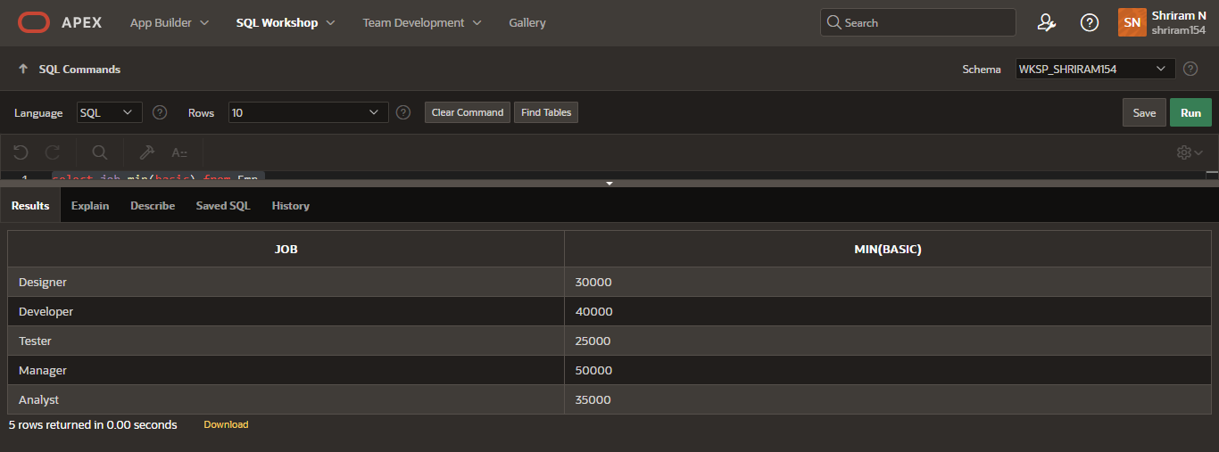

1. CreatetheDEPTtablebasedontheDEPARTMENTfollowingthetableinstancechartbelow.Confirmthatthetableiscreated.

CreatetableDEPT(

ID Number(7),Namevarchar(25)

);

DescDEPT;

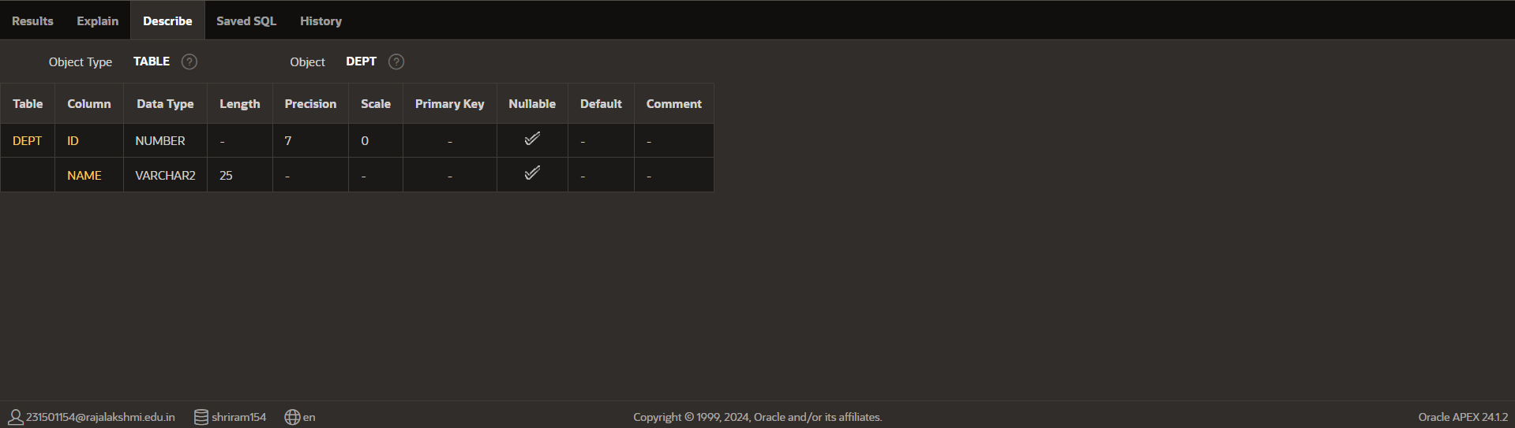

1. CreatetheEMP1tablebasedonthefollowinginstancechart.Confirmthatthetableiscreated.

create table EMP1(IDNumber(7),

First_name varchar(25),Last_name varchar(25),Dept_idNumber(7)

);

DescEMP1;

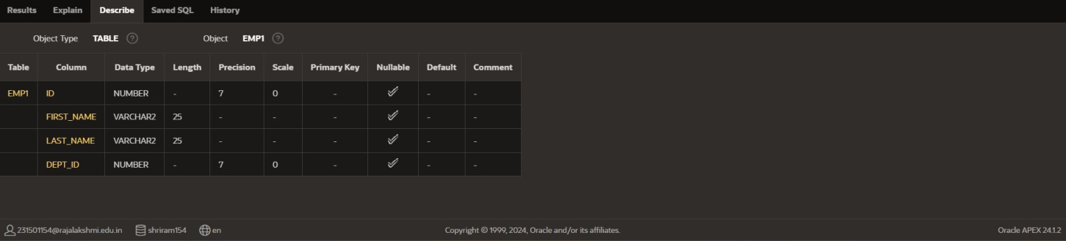

1. ModifytheEMP1tabletoallowforlongeremployeelastnames.Confirmthemodification.(Hint:Increasethesizeto50)

ALTERTABLEEMP1

modifyLast_namevarchar(50);

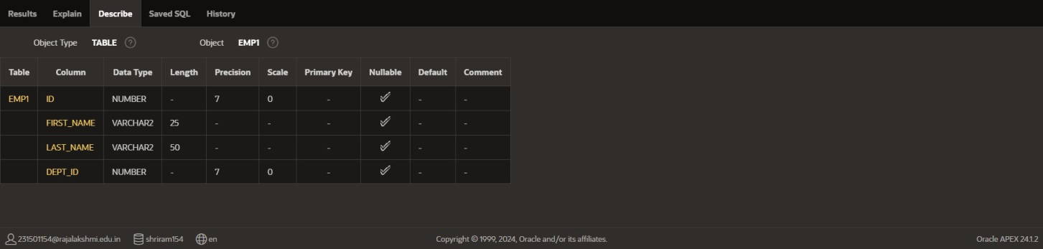

1. Create the EMPLOYEES2 table based on the structure of EMPLOYEES table.IncludeOnlytheEmployee_id,First_name,Last_name,SalaryandDept_idcoloumns.NamethecolumnsId,First_name,Last_name,salaryandDept_idrespectively.

create table EMPLOYEES2(ID Number(10),First_name varchar(50),Last_name varchar(50),Salary Number(10),Dept_idNumber(10)

);

1. DroptheEMP1table.droptableEMP1;
2. RenametheEMPLOYEES2tableasEMP1.

ALTERTABLEEMPLOYEES2RENAMETOEMP1;

1. AddacommentonDEPTandEMP1tables.Confirmthemodificationbydescribingthetable.

commentonTABLEDEPTIS'thistablecontainsthefieldsIDandNAME..';SELECTTABLE_NAME,COMMENTS

FROMUSER_TAB_COMMENTS

WHERETABLE_NAME='DEPT';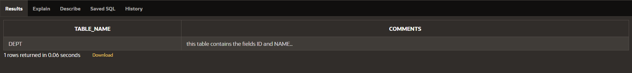

commentonTABLEEMP1IS'thistablecontainsthefieldsID,firstname,lastname,salary,DEPT_id..';

SELECT TABLE_NAME, COMMENTSFROM USER_TAB_COMMENTSWHERETABLE_NAME='EMP1';

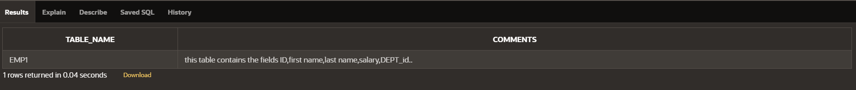

1. DroptheFirst_namecolumnfromtheEMPtableandconfirmit.

ALTERTABLEEMP1

dropcolumnFirst_name;

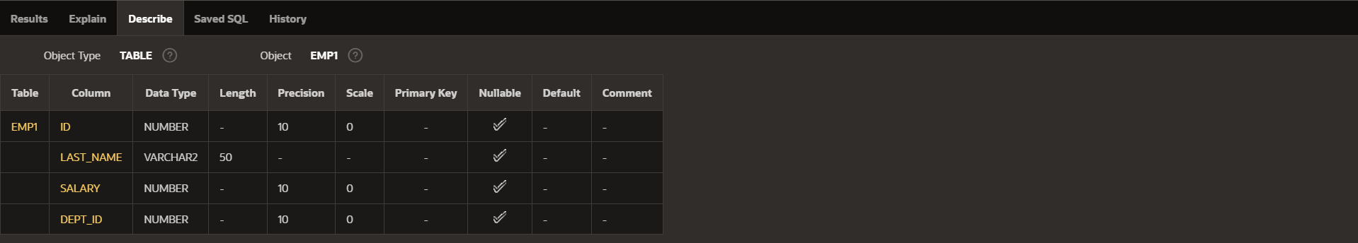

|  |  |  |
| --- | --- | --- |
| **Ex.No.: 3** | | **WRITING BASIC SQL SELECT STATEMENTS** |
| **Date:** | 10/08/2024 |

FindtheSolutionforthefollowing:

TrueORFalse

1.Thefollowingstatementexecutessuccessfully.

IdentifytheErrors

SELECT employee_id, last_namesal*12ANNUAL SALARY

FROMemployees;

FALSE

The columns in select statement should be separated by commas and the column alias shouldbegiven byusing akeyword“as”

SELECT employee_id, last_name, salary*12 as "ANNUAL SALARY"FROMemployees;

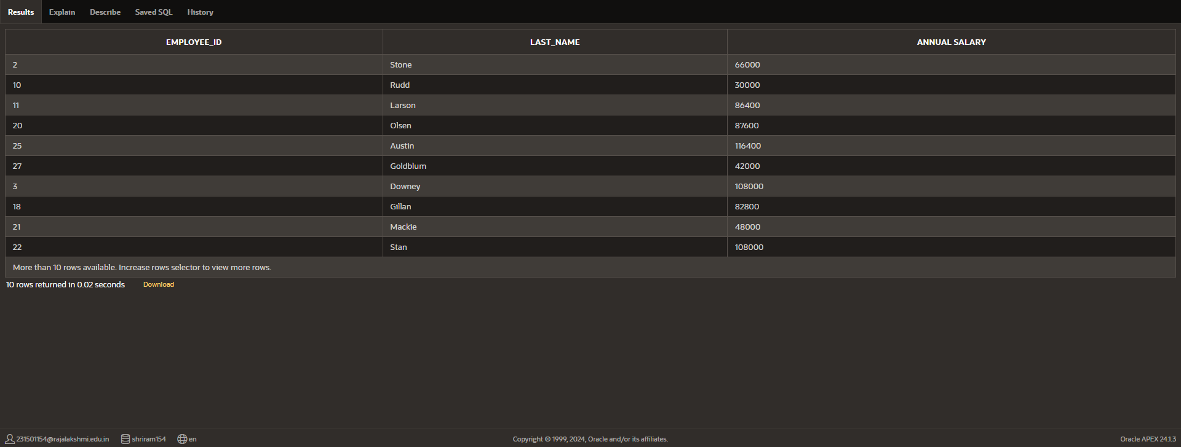

2)Showthestructureofdepartmentsthetable.Selectallthedatafromit.

Descemployees;

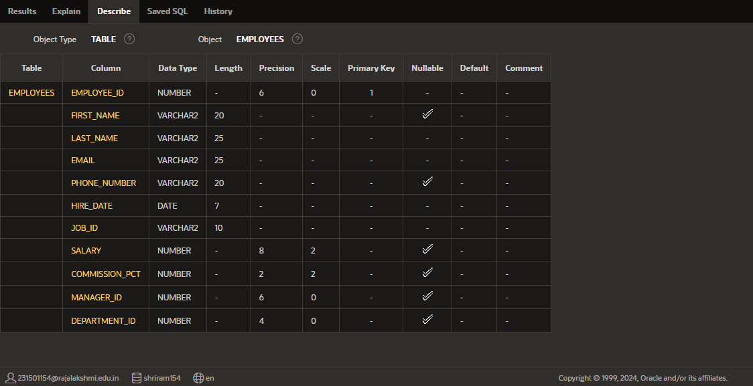

3. Create a query to display the last name, job code, hire date, and employee number foreachemployee, withemployee number appearingfirst.

selectemployee_id,job_id,last_name,hire_datefromemployees;

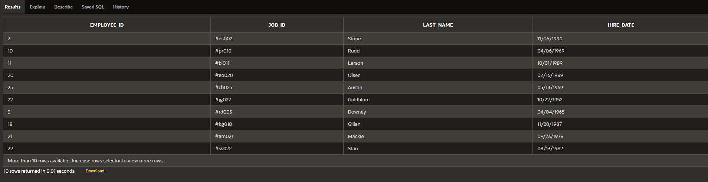

1. Provide an alias STARTDATE for the hire date.selecthire_dateas"STARTDATE"fromemployees;

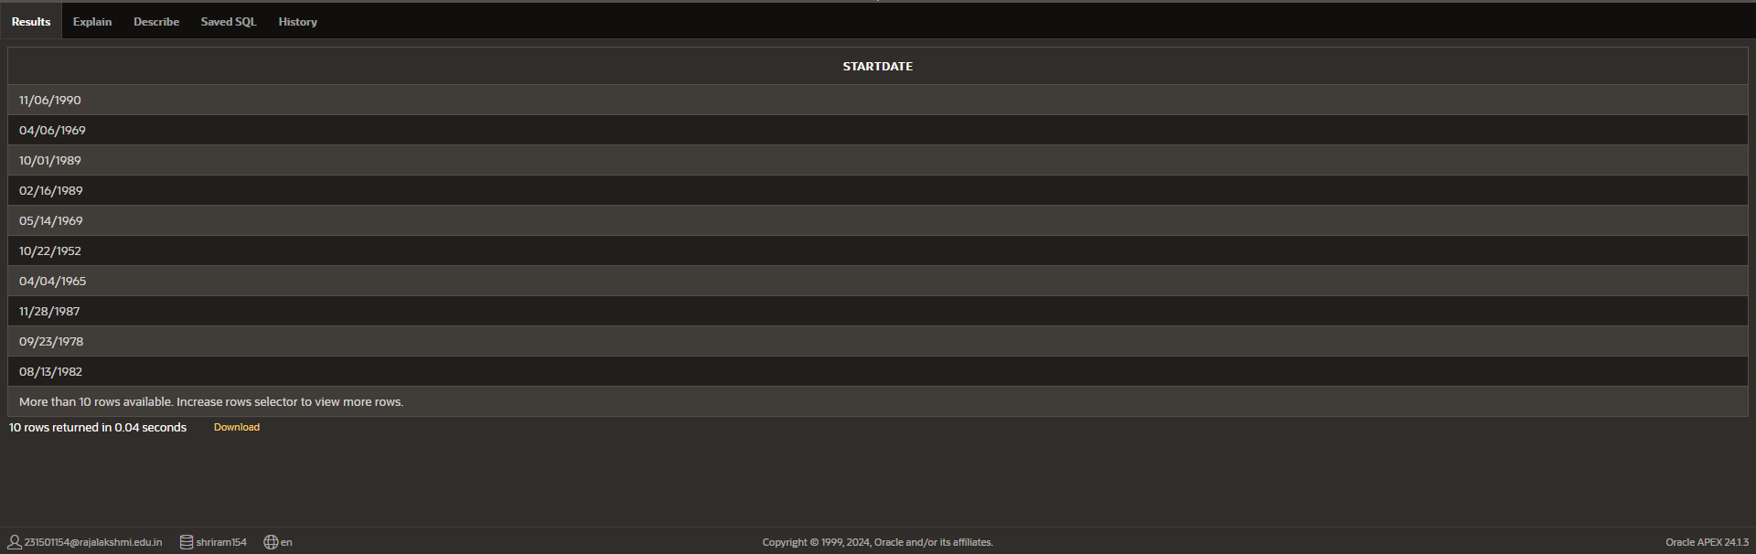

1. Create a query to display unique job codes from the employee table.selectdistinct(job_id) fromemployees;

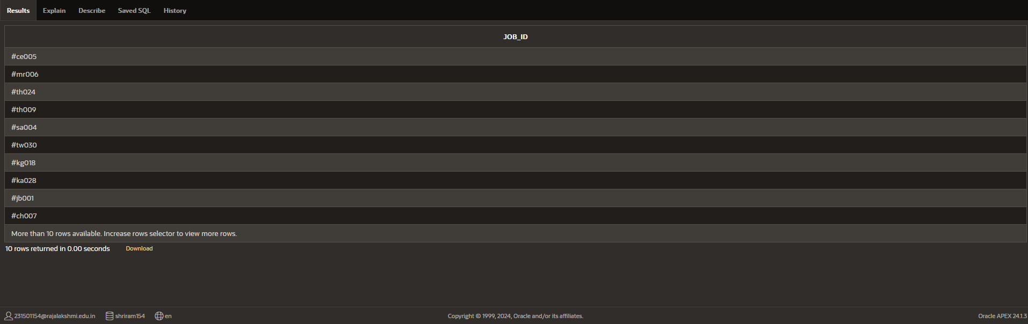

1. Display the last name concatenated with the job ID , separated by a comma and space,andnamethecolumnEMPLOYEE and TITLE.

selectlast_name||''||','||''||job_idas"EMPLOYEEANDTITLE"fromemployees;

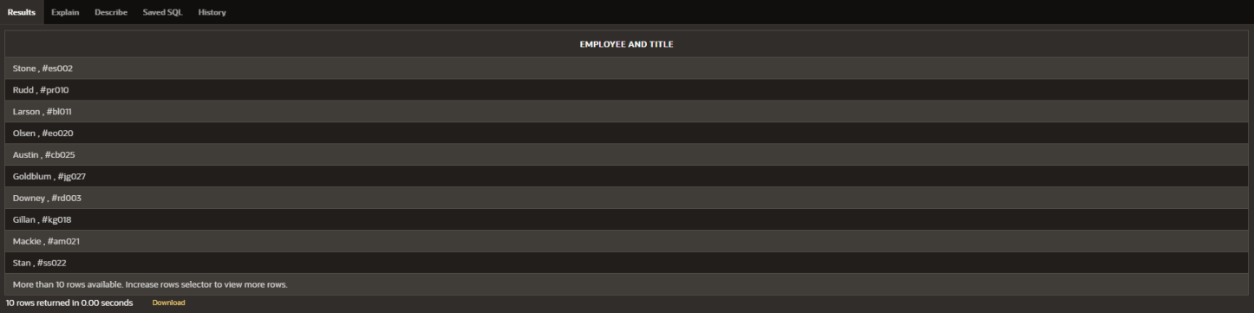

1. Create a query to display all the data from the employees table. Separate each column byacomma.Namethe columnTHE_OUTPUT.

selectemployee_id||','||first_name||','||last_name||','||email||','||phone_number||',' || hire_date || ' , ' || job_id || ' , ' || salary || ' , ' || commission_pct || ' , ' || manager_id || ' , ' ||department_idas"THE_OUTPUT"

fromemployees;

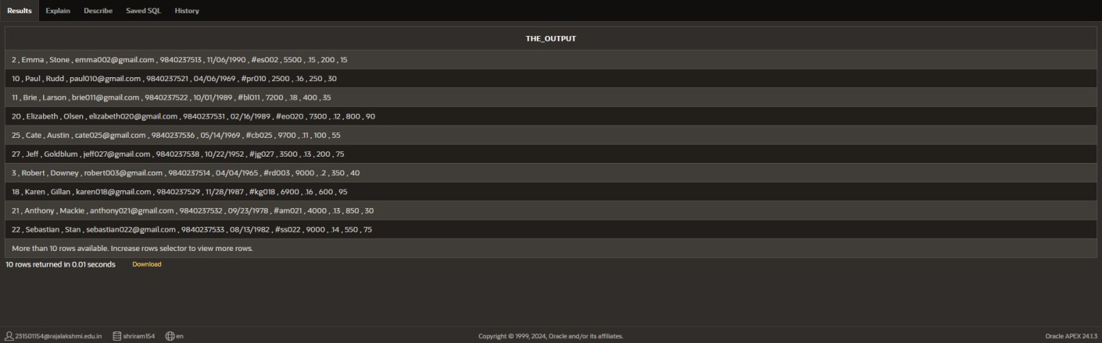

|  |  |  |
| --- | --- | --- |
| **Ex.No.: 4** | | **WORKING WITH CONSTRAINTS** |
| **Date:** | 16/08/2024 |

* 1. Add a table-level PRIMARY KEY constraint to the EMP table on the ID column.Theconstraintshouldbenamedatcreation.Nametheconstraintmy_emp_id_pk.

altertableEMP1

addconstraintmy_emp_id_pkPRIMARYKEY(ID);

* 1. Create a PRIMAY KEY constraint to the DEPT table using the ID colum. The constraintshouldbenamedatcreation. Nametheconstraint my_dept_id_pk.

altertableDEPT

addconstraintmy_dept_id_pkPRIMARYKEY(ID);

* 1. Add a column DEPT_ID to the EMP table. Add a foreign key reference on the EMP tablethat ensures that the employee is not assigned to nonexistent deparment. Name theconstraintmy_emp_dept_id_fk.

altertableemp

addDEPT_IDNumbe(10);

altertableemp

addconstraintmy_emp_dept_id_fkFOREIGNKEY(DEPT_ID)referencesdept(ID);

* 1. Modify the EMP table. Add a COMMISSION column of NUMBER data type, precision2, scale 2. Add a constraint to the commission column that ensures that a commissionvalueisgreaterthanzero.

altertableemp

addCOMMISSIONNumber(2,2);

altertableemp

addCONSTRAINTcommission_gt_zeroCHECK(COMMISSION>0);

|  |  |  |
| --- | --- | --- |
| **Ex.No.: 5** | | **CREATINGVIEWS** |
| **Date:** | 23/08/2024 |

1. Create a view called EMPLOYEE_VU based on the employee numbers, employeenames and department numbers from the EMPLOYEES table. Change the heading fortheemployee nametoEMPLOYEE.

createviewEMPLOYEE_VUas

select employee_id , first_name || ' ' || last_name as "EMPLOYEE", department_idfromemployees;

1. Display the contents of the EMPLOYEES_VU view.select*fromEMPLOYEE_VU;

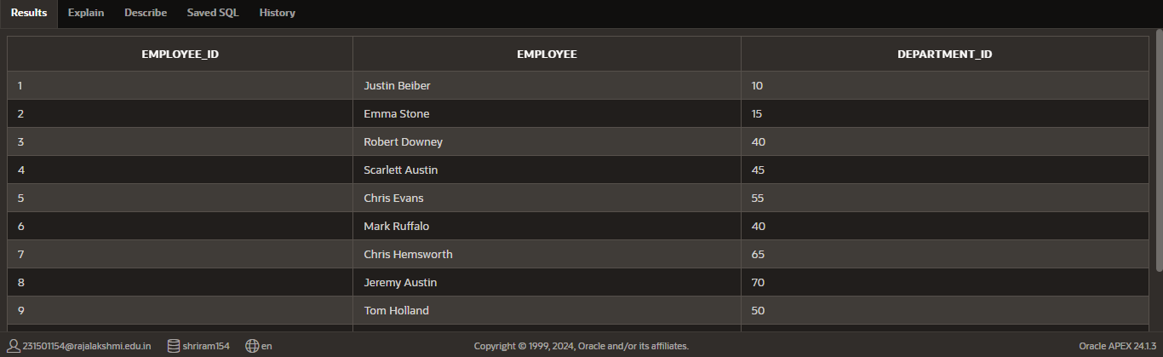

1. Select the view name and text from the USER_VIEWS data dictionary views.selectVIEW_NAME, TEXT

fromUSER_VIEWS

whereVIEW_NAME='EMPLOYEE_VU';

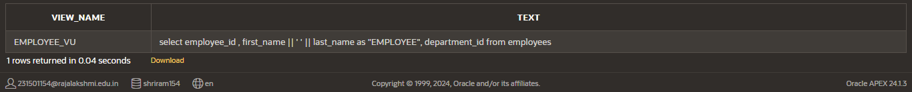

1. Using your EMPLOYEES_VU view, enter a query to display all employees names andDepartment.

SELECTemployee,department_id

FROMEMPLOYEE_VU;

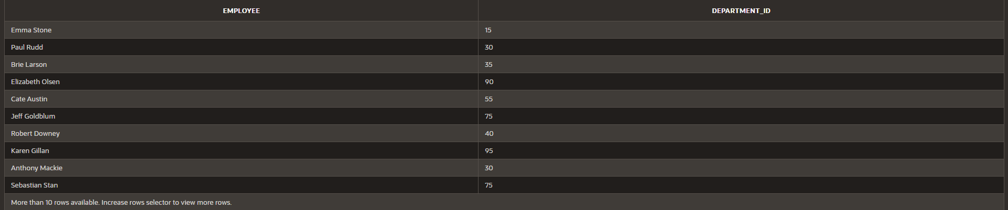

1. Create a view named DEPT50 that contains the employee number, employee lastnames and department numbers for all employees in department 50.Label the viewcolumns EMPNO, EMPLOYEE and DEPTNO. Do not allow an employee to bereassignedtoanother department throughthe view.

CREATEVIEWDEPT50AS

SELECT employee_id AS EMPNO,employee AS EMPLOYEE,department_idASDEPTNO

FROMEMPLOYEE_VU

WHERE department_id = 50WITHREAD ONLY;



1. DisplaythestructureandcontentsoftheDEPT50view.

Descdept50;

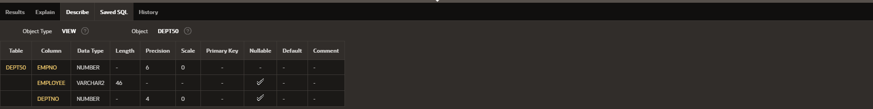

1. AttempttoreassignMatostodepartment80.

UPDATEEMPLOYEES

SET department_id = 80WHEREfirst_name='Matos';

1. Create a view called SALARY_VU based on the employee last names, departmentnames, salaries, and salary grades for all employees. Use the Employees,DEPARTMENTS and JOB_GRADE tables. Label the column Employee, Department,salary,and Graderespectively.

CREATEVIEWSALARY_VU AS

SELECT e.last_name AS Employee,d.dept_name AS Department,e.salaryASSalary,j.grade_levelAS Grade

FROM EMPLOYEES eJOINDEPARTMENTd

ON e.department_id = d.dept_idJOINJOB_GRADE j

ONe.salaryBETWEENj.lowest_salANDj.highest_sal;

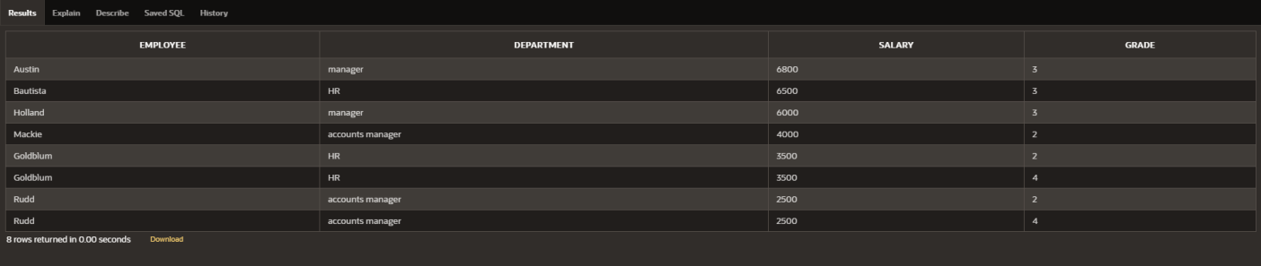

|  |  |  |
| --- | --- | --- |
| **Ex.No.: 6** | | **RESTRICTINGANDSORTINGDATA** |
| **Date:** | 29/08/2024 |

1. Create a query to display the last name and salary of employees earning more than12000.

selectsalary,last_namefromemployeeswheresalary>12000;

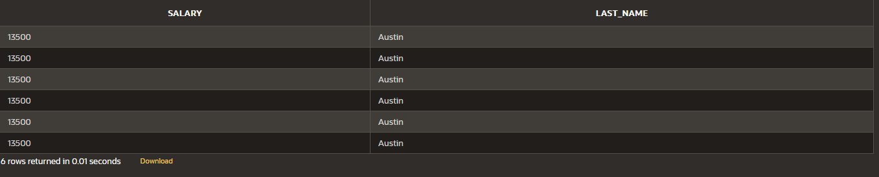

1. Create a query to display the employee last name and department number for employeenumber176.

select last_name , department_id from employeeswhereemployee_id =176;



1. Create a query to display the last name and salary of employees whose salary is not intherange of5000 and 12000.

select last_name , salary from employeeswheresalarynotbetween5000and12000;

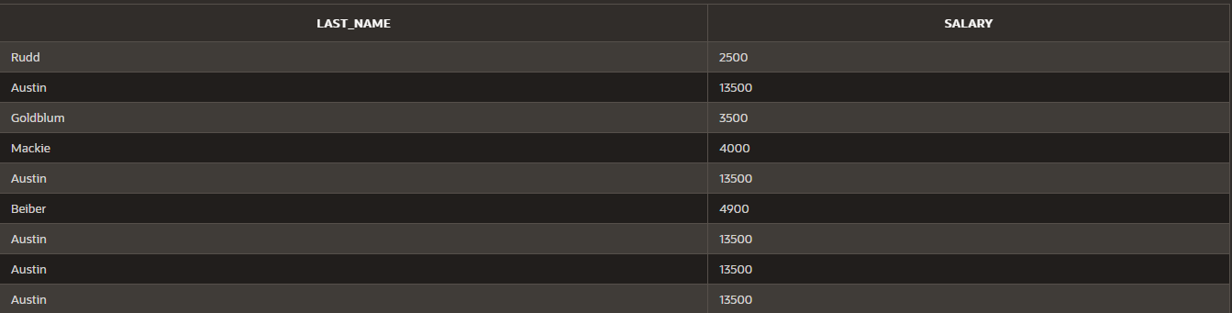



1. Display the employee last name, job ID, and start date of employees hired betweenFebruary 20,1998 and May 1,1998.order the query in ascending order by startdate.(hints:between)

select last_name, job_id, hire_date from employeeswherehire_datebetween'02-20-1998'and'05-01-1998';



1. Display the last name and department number of all employees in departments 20 and50inalphabetical orderbyname.

select last_name, department_id from employeeswhere department_id = 20 or department_id = 50orderbylast_name;

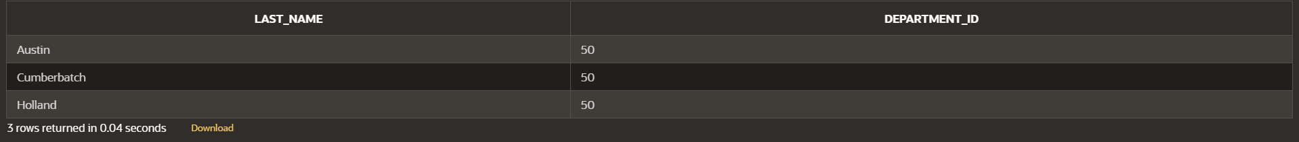

1. Display the last name and salary of all employees who earn between 5000 and 12000and are in departments 20 and 50 in alphabetical order by name. Label the columnsEMPLOYEE,MONTHLY SALARY respectively.

select last_name as "EMPLOYEE" , salary as "MONTHLY SALARY" from employeeswheredepartment_id in(20,50)and salarybetween 5000and 12000

orderbylast_name;



1. Display the last name and hire date of every employee who was hired in 1994.selectlast_name,hire_date fromemployees

wherehire_datelike'%1994%';



1. Displaythelastnameandjobtitleofallemployeeswhodonothaveamanager

select e.last_name, d.dept_name from employees ejoindepartment d

on e.department_id = d.dept_idwherenot(dept_name='manager');

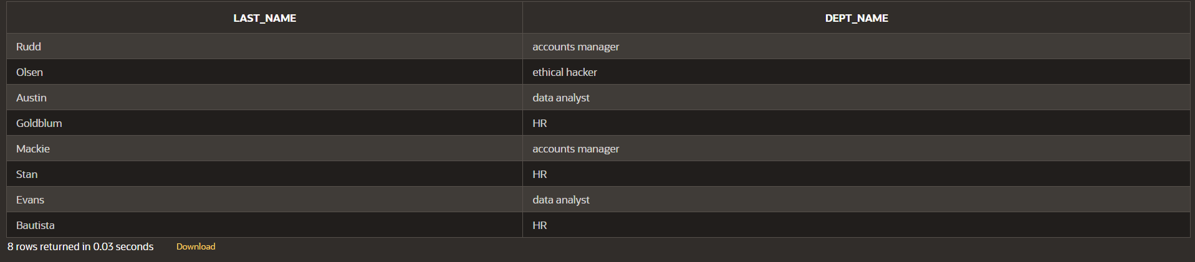

1. Display the last name, salary, and commission for all employees who earn commissions.Sortdataindescendingorderofsalaryandcommissions.(hints:isnotnul,orderby)

select last_name,salary,commission_pct from employeeswherecommission_pct isnot null

orderbysalary,commission_pctdesc;

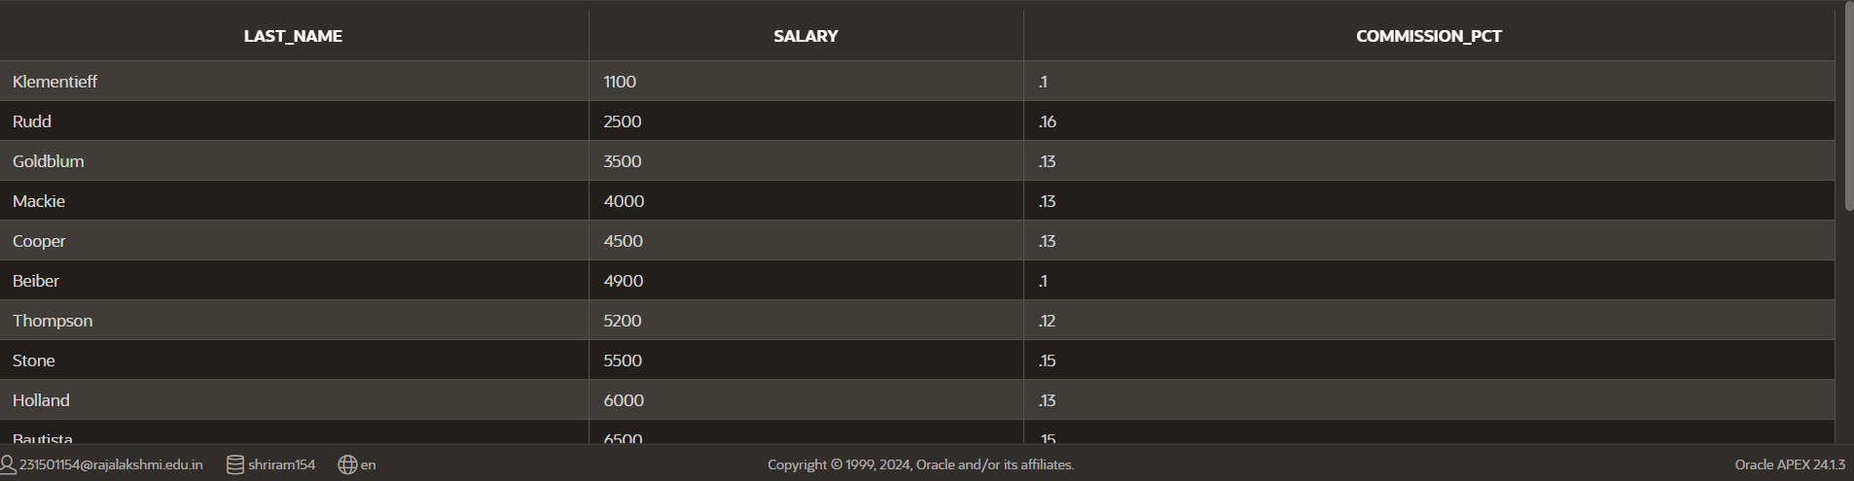

1. Displaythelastnameofall employeeswherethethirdletterofthenameisa.

selectlast_namefromemployeeswherelast_name like'a%';

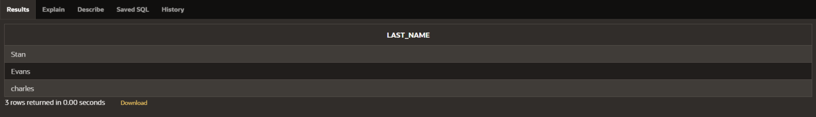

1. Displaythelastnameofallemployeeswhohaveanaandaneintheirlastname.

SELECTlast_nameFROMemployees

WHERElast_nameLIKE'%a%'ANDlast_nameLIKE'%e%';

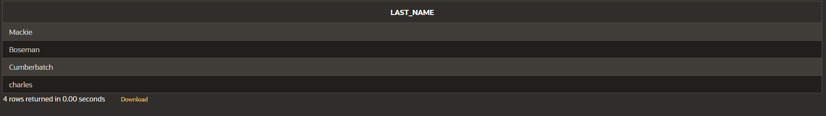

1. Display the last name and job and salary for all employees whose job is salesrepresentativeorstockclerkandwhosesalaryisnotequalto2500,3500or7000/.

SELECT e.last_name,e.salary,d.dept_name FROM employees ejoindepartment done.department_id=d.dept_id

WHERE (dept_name in ('stock clerk','sales representative')) and (salary notin(2500,3500,7000));



|  |  |  |
| --- | --- | --- |
| **Ex.No.: 7** | | **USING SET OPERATORS** |
| **Date:** | 30/08/2024 |

1. TheHRdepartmentneedsalistofdepartmentIDsfordepartmentsthatdonotcontainthejob IDST_CLERK. Usesetoperatorstocreatethisreport.

select dept_id from departmentminus

select department_id from employeeswherejob_id ='ST_CLERK';

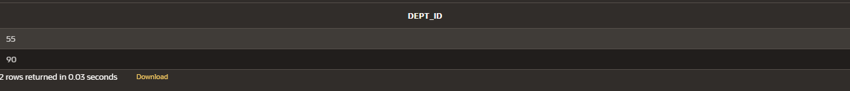

1. The HR department needs a list of countries that have no departments located inthem.Display the country ID and the name of the countries. Use set operators to createthisreport.

SELECT c.country_id, c.country_nameFROMcountries c

LEFTJOINdepartmentdONc.country_id=d.country_idWHEREd.country_id ISNULL;



1. Producealistofjobsfordepartments10,50,and20,inthatorder.DisplayjobIDanddepartmentIDusing setoperators.

SELECT job_id, department_idFROMemployees

WHERE department_id IN (10, 50, 20)ORDERBY department_id;

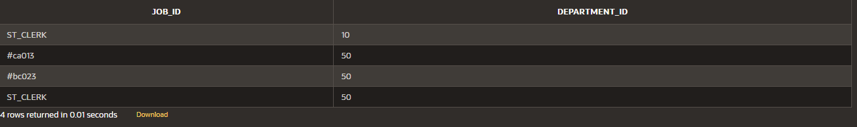

1. Create a report that lists the employee IDs and job IDs of those employees whocurrently have a job title that is the same as their job title when they were initiallyhired by the company (that is, they changed jobs but have now gone back to doingtheiroriginal job).

SELECT employee_id, job_idFROM employeesINTERSECT

SELECT employee_id, job_idFROMjob_history;

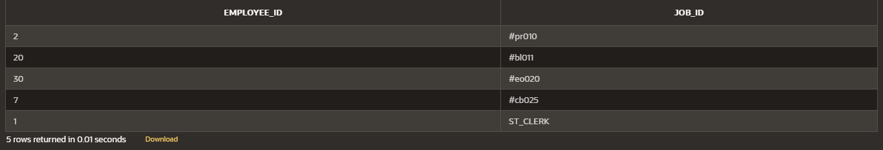

1. TheHRdepartmentneedsareportwiththefollowingspecifications:
   * Last name and department ID of all the employees from the EMPLOYEES table,regardlessofwhetherornot theybelong toadepartment.
   * Department ID and department name of all the departments from the DEPARTMENTStable, regardless of whether or not they have employees working in them Write acompoundquerytoaccomplish this.

SELECT last_name, department_id FROM employeesUNION

SELECTdept_name,dept_idFROMdepartment;



|  |  |  |
| --- | --- | --- |
| **Ex.No.: 8** | | **WORKING WITH MULTIPLE TABLES** |
| **Date:** | 05/09/2024 |

1. Writeaquerytodisplaythelastname,departmentnumber,anddepartmentnameforallEmployees.

select e.last_name , e.department_id , d.dept_namefromemployeese

joindepartmentdone.department_id=d.dept_id;

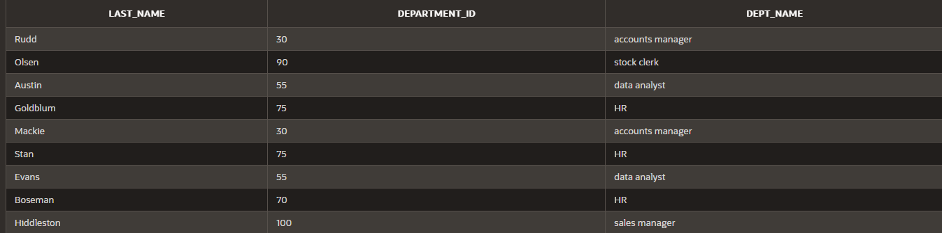

1. Create a unique listing of all jobs that are in department 80. Include the location of thedepartmentintheoutput.

select d.dept_name,d.location_idfromdepartmentd

join employees e on d.dept_id = e.department_idwheredepartment_id =80;

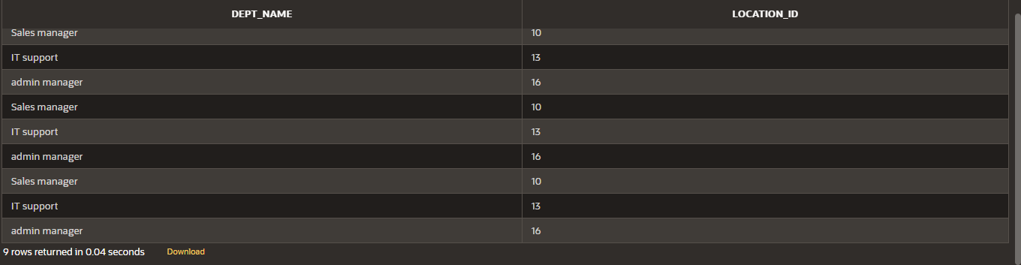

1. Write a query to display the employee last name, department name, location ID, and cityofall employees who earnacommission

select e.last_name,d.dept_name,d.location_id,l.cityfrom(departmentd

inner join employees e on d.dept_id = e.department_idinner join location l on d.location_id = l.location_id)wherecommission_pct isnot null;

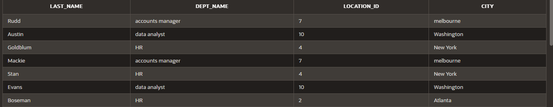



1. Display the employee last name and department name for all employees who have ana(lowercase)intheir last names.

select e.last_name,d.dept_namefromdepartmentd

inner join employees e on d.dept_id = e.department_idwherelast_name like'%a%';

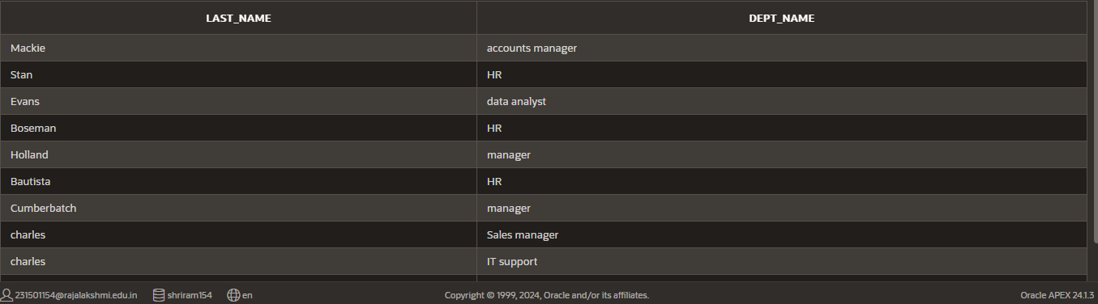

1. Write a query to display the last name, job, department number, and department nameforall employees who workinToronto.

select e.last_name,d.dept_name,e.department_idfrom(departmentd

inner join employees e on d.dept_id = e.department_idinner join location l on l.location_id = d.location_id)wherecity='Toronto';

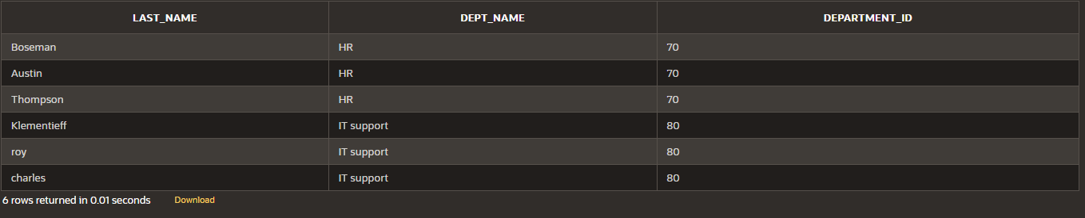

1. Display the employee last name and employee number along with their manager‘s lastnameandmanagernumber.LabelthecolumnsEmployee,Emp#,Manager,andMgr#,

Respectively

select last_name as "Employee",employee_id as "Emp#",manager_id as "Mgr#" fromemployees;

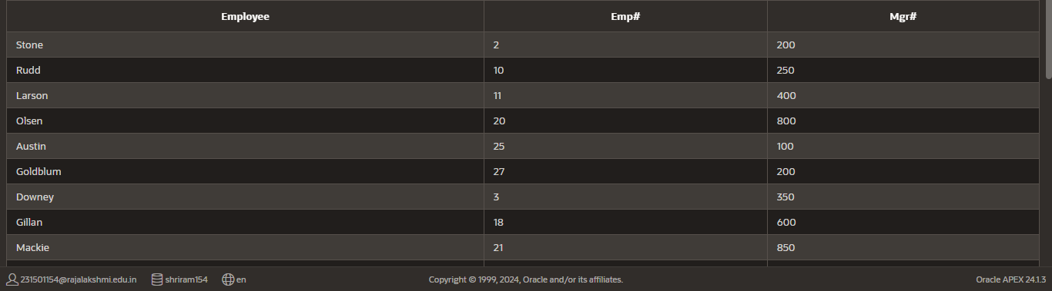

1. Modify lab4_6.sql to display all employees including King, who has no manager. Ordertheresultsbytheemployee number.

SELECT last_name AS "Employee",employee_id AS "Emp#",manager_id AS "Mgr#"FROMemployeesORDERBYemployee_id;

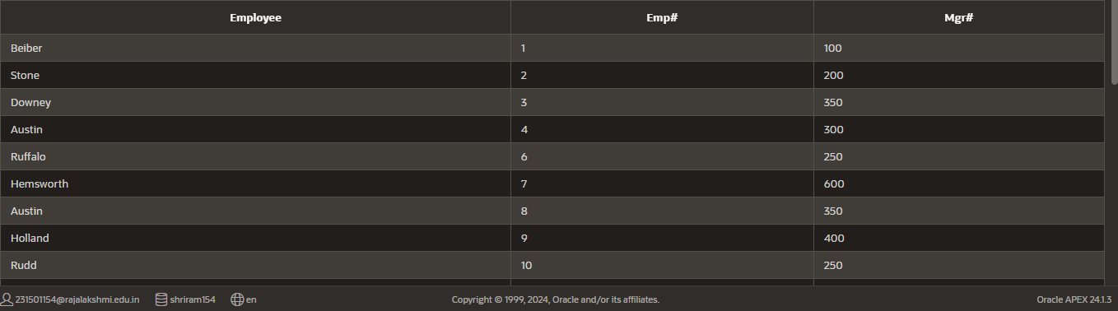

1. Create a query that displays employee last names, department numbers, and all theemployees who work in the same department as a given employee. Give each columnanappropriate label

select e.last_name as "Employee",d.dept_name as "department_name",e.department_idas"department_no"fromemployeese

innerjoindepartmentdone.department_id=d.dept_id;

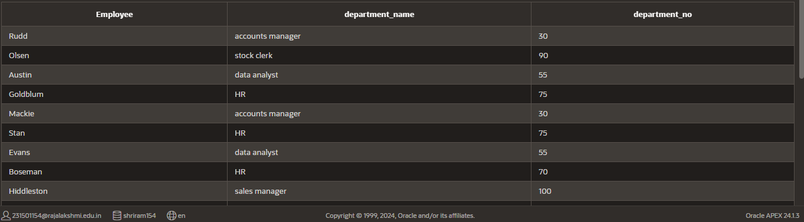

1. ShowthestructureoftheJOB_GRADEStable.Createaquerythatdisplaysthename,job,

departmentname,salary,andgradeforallemployees

descjob_grade;

SELECT e.first_name || ' ' || last_name AS "Employee",d.dept_name,e.salary,g.grade_level as"GRADE"

FROM(employeese

innerjoindepartmentdone.department_id=d.dept_id

innerjoinjob_gradegone.department_id=g.department_id);

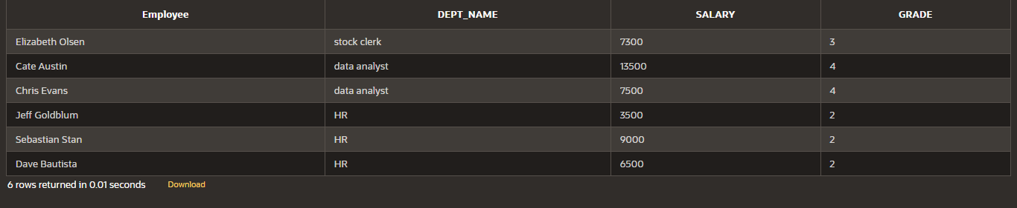

1. Create a query to display the name and hire date of any employee hired after employeeDavies.

SELECT last_name,hire_date FROM employeeswherehire_date >'05-03-1986';

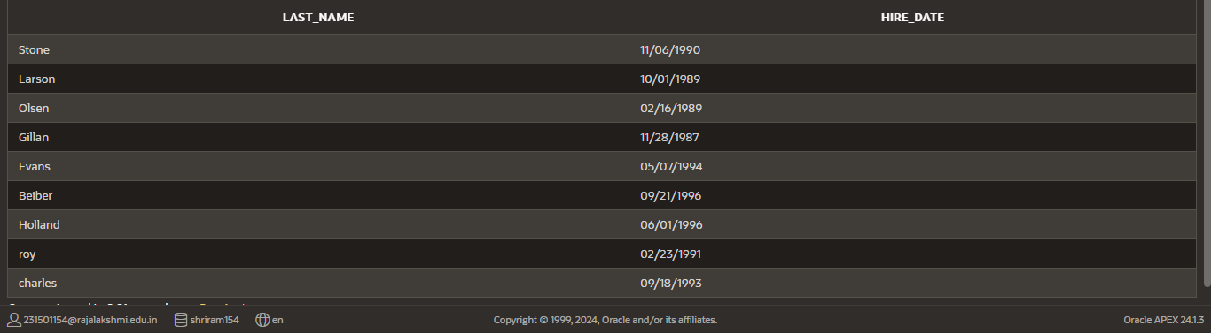

1. Display the names and hire dates for all employees who were hired before their managers,along with their manager‘s names and hire dates. Label the columns Employee, Emp Hired,Manager,and MgrHired, respectively.

SELECTlast_nameas"employee",hire_dateas"employeehired"FROMemployees;

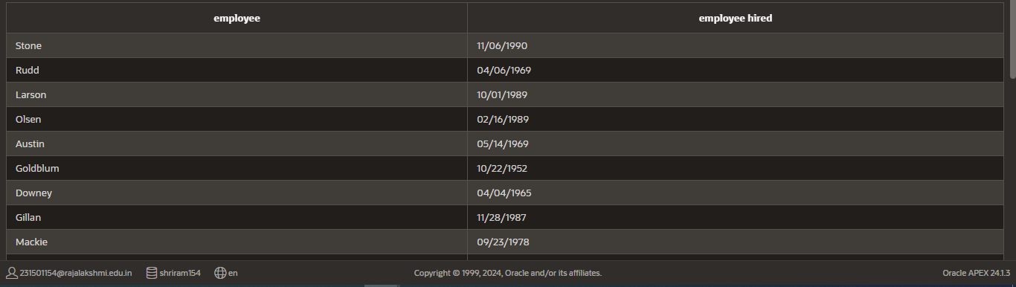

|  |  |  |
| --- | --- | --- |
| **Ex.No.: 9** | | **SUB QUERIES** |
| **Date:** | 06/09/2024 |

* 1. The HR department needs a query that prompts the user for an employee last name.The query then displays the last name and hire date of any employee in the samedepartment as the employee whose name they supply (excluding that employee). Forexample, if the user enters Zlotkey, find all employees who work with Zlotkey (excludingZlotkey).

SELECT last_name, hire_dateFROMemployees

WHERE department_id = ALL(SELECT department_idFROMemployees

WHERElast_name='Zlotkey'

)

ANDlast_name!='Zlotkey';

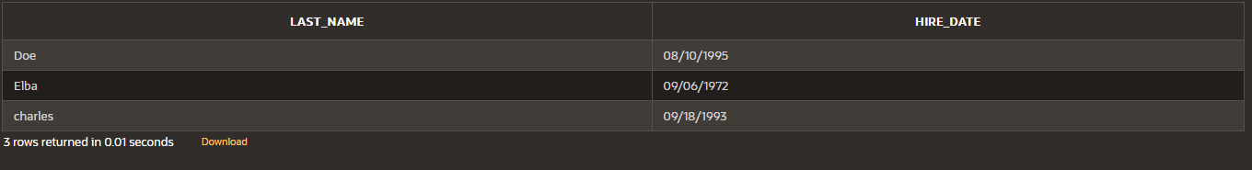

* 1. Createareportthatdisplaystheemployeenumber,lastname,andsalaryofallemployees who earn more than the average salary. Sort the results in order ofascendingsalary.

SELECTEMPLOYEE_ID,LAST_NAME,SALARY

FROM employeesWHERESALARY>(

SELECTAVG(SALARY)

FROMemployees

)

ORDERBYSALARY ASC;

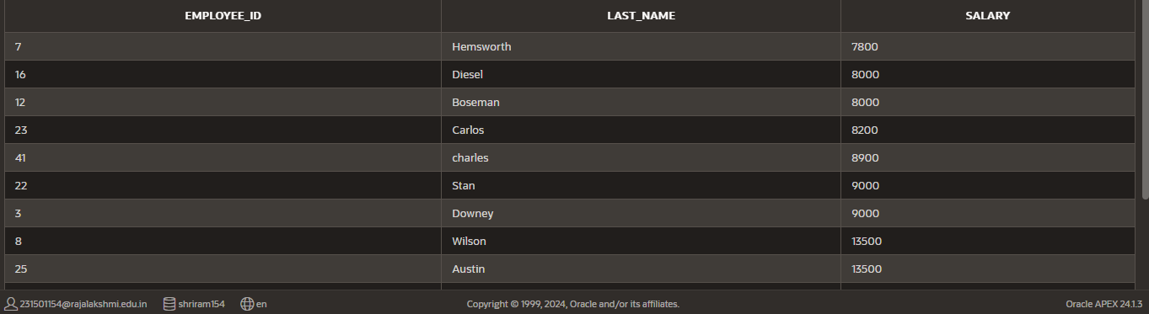

* 1. Write a query that displays the employee number and last name of all employees whoworkinadepartment withanyemployee whose lastnamecontainsau.

SELECTEMPLOYEE_ID,LAST_NAME

FROMemployees

WHERE DEPARTMENT_ID IN (SELECTDEPARTMENT_ID

FROMemployees

WHERELAST_NAMELIKE'%a%'andLAST_NAMELIKE'%u%');

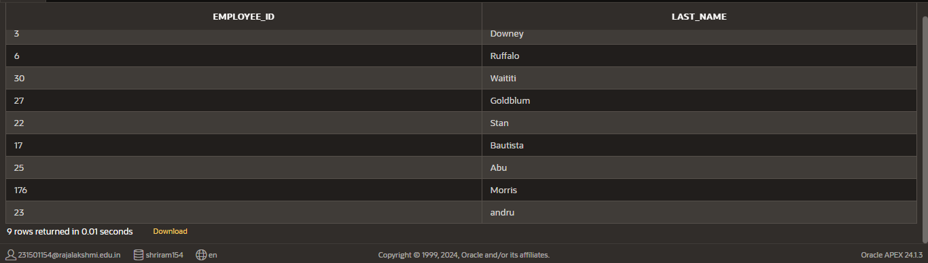

* 1. The HR department needs a report that displays the last name, department number, andjobIDofall employeeswhose department location IDis1700.

SELECTe.last_name,e.department_id,e.job_id

FROMemployeese

INNER JOIN department d ON e.department_id = d.dept_idWHEREe.department_id IN(

SELECT dept_idFROMdepartment

WHERElocation_id=1700);

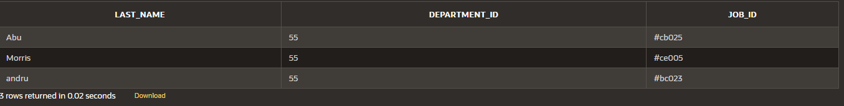

* 1. Create a report for HR that displays the last name and salary of every employee whoreportstoKing.

SELECT e.last_name, e.salaryFROMemployeese

WHERE e.manager_id IN (SELECT d.manager_idFROMdepartment d

WHEREd.manager_name='king');

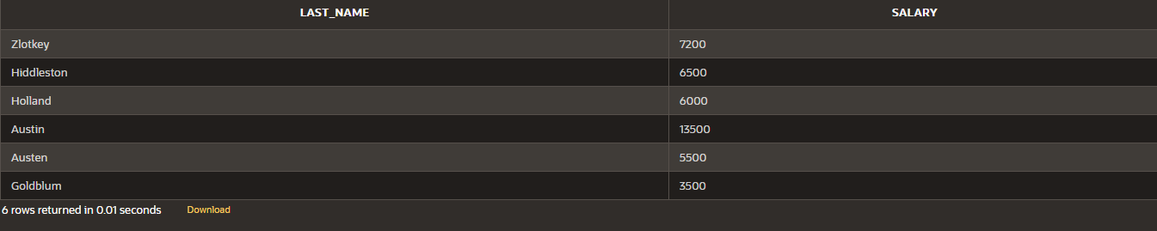

* 1. CreateareportforHRthatdisplaysthedepartmentnumber,lastname,andjobIDforeveryemployee intheExecutive department.

SELECT e.department_id, e.last_name, e.job_idFROMemployeese

JOIN department d on e.department_id = d.dept_idWHEREd.dept_name ='executive';

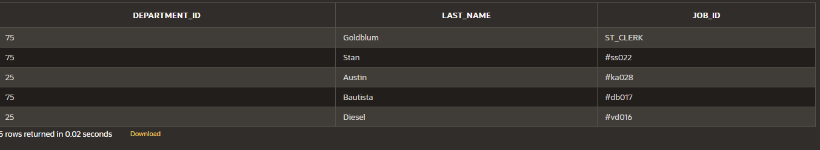

* 1. Modify the query 3 to display the employee number, last name, and salary of allemployees who earn more than the average salary and who work in a department withanyemployee whose lastnamecontainsa u.

SELECT e.employee_id, e.last_name, e.salaryFROMemployeese

WHERE e.salary > (SELECT AVG(salary)FROMemployees

)

AND e.department_id IN (SELECT x.department_idFROMemployeesx

WHEREx.last_nameLIKE'%a%'ANDx.last_nameLIKE'%u%'

);

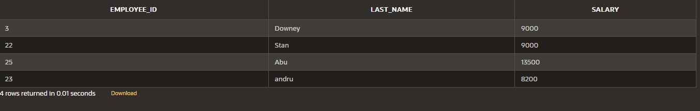

|  |  |  |
| --- | --- | --- |
| **Ex.No.: 10** | | **AGGREGATINGDATAUSINGGROUPFUNCTIONS** |
| **Date:** | 12/09/2024 |

**FindtheSolutionforthefollowing:**

Determinethevalidityofthefollowingthreestatements.CircleeitherTrueorFalse.

1. Groupfunctionsworkacrossmanyrowstoproduceoneresultpergroup.True/False-TRUE
2. Group functions include nulls in calculations.True/False- FALSE
3. TheWHEREclauserestrictsrowspriortoinclusioninagroupcalculation.True/False-FALSE
4. Find the highest, lowest, sum, and average salary of all employees. Label thecolumnsMaximum,Minimum,Sum,andAverage,respectively.Roundyourresultstothenearestwhole number

SELECTROUND(MAX(salary))ASMaximum,ROUND(MIN(salary))ASMinimum,ROUND(SUM(salary))ASSum,ROUND(AVG(salary)) ASAverage

FROMemployees;



1. Modifytheabovequerytodisplaytheminimum,maximum,sum,andaveragesalaryforeachjobtype.

SELECTROUND(MAX(salary))ASMaximum,ROUND(MIN(salary))ASMinimum,ROUND(SUM(salary))ASSum,ROUND(AVG(salary)) ASAverage

FROM employeesjoindepartment

ondepartment.dept_id=employees.department_idgroupbydept_name;

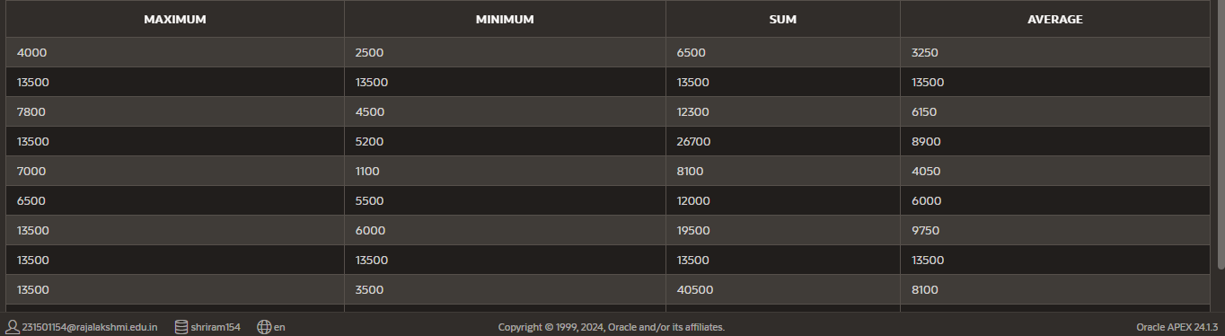

1. Writeaquerytodisplaythenumberofpeoplewiththesamejob.Generalizethequerysothat

theuserintheHRdepartmentispromptedforajobtitle.

SELECTd.dept_name,COUNT(*)ASNumberOfEmployeesFROMEmployeese

joindepartmentdone.department_id=d.dept_idgroupbyd.dept_name;

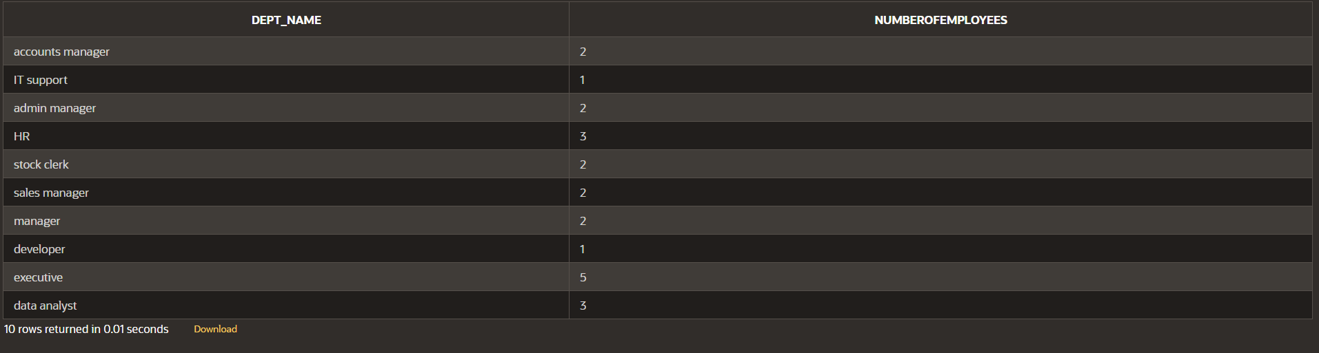

1. Determinethenumberofmanagerswithoutlistingthem.LabelthecolumnNumberofManagers

SELECTCOUNT(DISTINCTMANAGER_ID)AS"NumberofManagers"

FROMEmployees

WHEREMANAGER_IDISNOTNULL;



1. Findthedifferencebetweenthehighestandlowestsalaries.LabelthecolumnDIFFERENCE.

selectmax(salary)-min(salary)as"DIFFERENCE"fromemployees;



1. Create a report to display the manager number and the salary of the lowest-paidemployeeforthatmanager.Excludeanyonewhosemanagerisnotknown.Excludeanygroups where the minimum salary is $6,000 or less. Sort the output in descending orderofsalary.

SELECTMANAGER_ID,MIN(SALARY)AS"LowestSalary"

FROMEmployees

WHEREMANAGER_IDISNOTNULLGROUPBYMANAGER_ID

HAVINGMIN(SALARY)>6000

ORDERBY"LowestSalary"DESC;

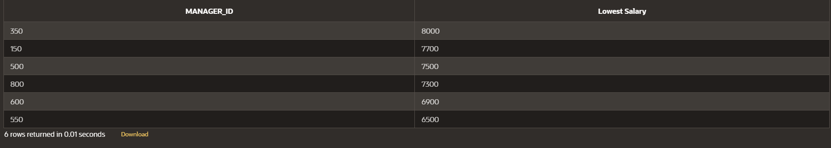

1. Createaquerytodisplaythetotalnumberofemployeesand,ofthattotal,thenumberofemployeeshiredin1995,1996,1997,and1998.Createappropriate

columnheadings.

SELECTEXTRACT(YEARFROMhire_date)AS"yearlywiseemployment",COUNT(*)FROMemployees

GROUPBYEXTRACT(YEARFROMhire_date)

HAVINGEXTRACT(YEARFROMhire_date)IN(1995,1996,1997,1998);



1. Create a matrix query to display the job, the salary for that job based on departmentnumber,andthetotalsalaryforthatjob,fordepartments20,50,80,and90,givingeachcolumnanappropriateheading.

selectd.dept_name,sum(e.salary)fromemployees e

joindepartmentdone.department_id=d.dept_idwheredepartment_idin(20,50,80,90)

groupbyd.dept_name;



1. Writeaquerytodisplayeachdepartment‘sname,location,numberofemployees,andthe

averagesalaryforalltheemployeesinthatdepartment.Labelthecolumnname-Location,

Numberofpeople,andsalaryrespectively.Roundtheaveragesalarytotwodecimalplaces.

SELECT d.dept_name AS "Name", d.Location_id AS "Location",COUNT(e.department_id)AS"NumberofPeople",ROUND(AVG(e.Salary),2)AS"Salary"

FROMdepartmentd

JOINemployeeseONd.dept_id=e.department_id

GROUPBYd.dept_name,d.location_id;

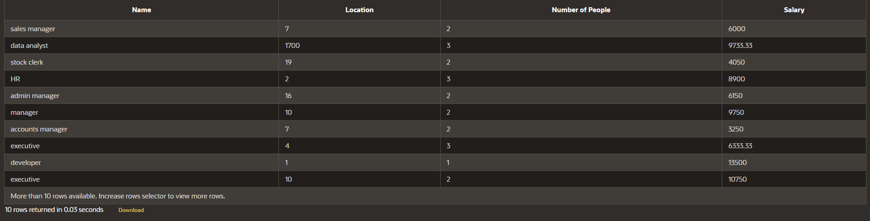

|  |  |  |
| --- | --- | --- |
| **Ex.No.: 11** | | **PL SQL PROGRAMS** |
| **Date:** | 13/09/2024 |

**PROGRAM1**

**WriteaPL/SQLblocktocalculatetheincentiveofanemployeewhoseIDis110.**

DECLARE

pl_emp_id employees.employee_id%TYPE := 110;pl_salaryemployees.salary%TYPE;

pl_incentive NUMBER;BEGIN

SELECT salary INTO pl_salaryFROMemployees

WHEREemployee_id=pl_emp_id;

pl_incentive:=pl_salary*0.10;UPDATEemployees

SET incentive = pl_incentiveWHEREemployee_id=pl_emp_id;

DBMS_OUTPUT.PUT_LINE('Incentive for employee ID ' || pl_emp_id || ' is ' ||pl_incentive);

COMMIT;

END;

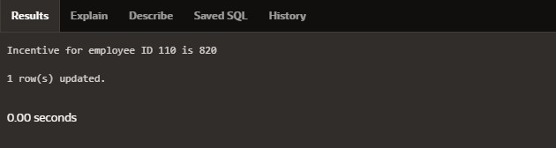

**PROGRAM2**

**WriteaPL/SQLblocktoshowaninvalidcase-insensitivereferencetoaquotedandwithoutquoted user-definedidentifier**.

DECLARE

employeeNameVARCHAR2(100);"EmployeeID"NUMBER;

BEGIN

employeeName := 'John Doe';"EmployeeID":=40;

DBMS_OUTPUT.PUT_LINE('Employee Name: ' || employeeName);DBMS_OUTPUT.PUT_LINE('Employee ID:'||"EmployeeID");

END;

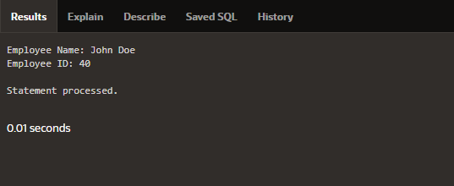

**PROGRAM3**

**WriteaPL/SQLblocktoadjustthesalaryoftheemployeewhoseID122.Sampletable:employees**

**DECLARE**

**v_employee_id NUMBER := 122;v_salary NUMBER;v_new_salaryNUMBER;**

**v_increase_percentage NUMBER := 0.40;BEGIN**

**SELECT salary INTO v_salaryFROMemployees**

**WHEREemployee_id=v_employee_id;**

**v_new_salary := v_salary + (v_salary * v_increase_percentage / 100);UPDATEemployees**

**SETsalary=v_new_salary**

**WHEREemployee_id=v_employee_id;**

**DBMS_OUTPUT.PUT_LINE('Employee ID ' || v_employee_id || ' new salary: ' ||v_new_salary);**

**END;**

**PROGRAM4**

**WriteaPL/SQLblocktocreateaprocedureusingthe"IS[NOT]NULLOperator"andshow ANDoperatorreturnsTRUEifandonlyifbothoperandsareTRUE.**

**create or replace procedure check_nullis**

**value1 number := 10;value2number:=null;**

**begin**

**if value1 is not null and value2 is null thendbms_output.put_line('Bothvaluesarenotnull!!');**

**else**

**dbms_output.put_line('Null value found');end if;**

**end;**

**BEGIN**

**check_null;END;**

**PROGRAM5**

**Write a PL/SQL block to describe the usage of LIKE operator including wildcardcharactersand**

**escapecharacter.**

**declare**

**v_employeename employees.first_name%type;v_employeeidNUMBER :=122;**

**begin**

**selectfirst_nameintov_employeenamefromemployees**

**where first_name like '%e%' and employee_id = v_employeeid;DBMS_OUTPUT.PUT_LINE(v_employeename);**

**END;**

**PROGRAM6**

**Write a PL/SQL program to arrange the number of two variable in such a way that thesmallnumberwillstoreinnum_smallvariableandlargenumberwillstoreinnum_largevariable.**

**declare**

**abnumber:=10;**

**cd number :=20;num_small number;num_large number;begin**

**if ab>cd thennum_small :=cd;num_large :=ab;else**

**num_small :=ab;num_large :=cd;endif;**

**dbms_output.put_line('small number = '||num_small);dbms_output.put_line('large number = '||num_large);End;**

**PROGRAM7**

**Write a PL/SQL procedure to calculate the incentive on a target achieved and display themessageeithertherecordupdated ornot.**

**create or replace procedure calculate_incentive(p_emp_idemployees.employee_id%type,p_targetnumber)**

**is**

**v_incentivenumber(7,2);v_salaryemployees.salary%type;**

**begin**

**select salary into v_salaryfromemployees**

**whereemployee_id=p_emp_id;**

**if p_target >= 100000 thenv_incentive:=v_salary*0.1;**

**dbms_output.put_line('Incentive of ' || v_incentive || ' calculated for employee ID ' ||p_emp_id);**

**else**

**dbms_output.put_line('No incentive for employee ID ' || p_emp_id);end if;**

**End;**

**PROGRAM8**

**Write a PL/SQL procedure to calculate incentive achieved according to the specific salelimit.**

**create or replace procedure incentive_sale(p_emp_id employees.employee_id%type,p_salesnumber)**

**is**

**v_incentive number(7,2);begin**

**if p_sales > 100000 thenv_incentive:=p_sales*0.1;**

**elsif p_sales between 50000 and 100000 thenv_incentive:=p_sales *0.05;**

**else**

**v_incentive := 0;endif;**

**dbms_output.put_line('Incentive for employee ID ' || p_emp_id || ' is: ' || v_incentive);End;**

**begin**

**incentive_sale(122,500000);end;**

**PROGRAM9**

**Write a PL/SQL program to count number of employees in department 50 and checkwhether this department have any vacancies or not. There are 45 vacancies in thisdepartment.**

**declare**

**no_of_emp number;vacancies number:=45;begin**

**select count(*) into no_of_emp from employees where department_id=50;ifno_of_emp<vacancies then**

**dbms_output.put_line('vacancies are available');else**

**dbms_output.put_line('vacancies are not available');end if;**

**end;**

**PROGRAM10**

**Write a PL/SQL program to count number of employees in a specific department andcheck whether this department have any vacancies or not. If any vacancies, how manyvacanciesareinthatdepartment.**

**declare**

**v_department_id number := 55;v_emp_count number;v_vacancies number:=50;**

**begin**

**select count(*) into v_emp_countfromemployees**

**wheredepartment_id=v_department_id;**

**ifv_emp_count<v_vacancies then**

**dbms_output.put_line('Vacancies available: ' || (v_vacancies - v_emp_count));else**

**dbms_output.put_line('No vacancies available.');end if;**

**end;**

**PROGRAM11**

**WriteaPL/SQLprogramtodisplaytheemployeeIDs,names,jobtitles,hiredates,andsalariesofallemployees.**

**begin**

**for i in (select employee_id, first_name || ' ' || last_name as name, job_id, hire_date,salaryfromemployees)**

**loop**

**dbms_output.put_line('ID:'||i.employee_id||',Name:'||i.name||',Job:'||i.job_id**

**||',HireDate:'||i.hire_date||',Salary:'||i.salary);endloop;**

**end;**

**PROGRAM12**

**Write a PL/SQL program to display the employee IDs, names, and department names ofallemployees.**

**begin**

**foriin(selecte.employee_id,e.first_name||''||e.last_nameasname,d.dept_namefromemployees e**

**join department d on e.employee_id = d.dept_id) loopdbms_output.put_line('ID:'||i.employee_id||',Name:'||i.name||',Department:'||**

**i.dept_name);endloop;**

**End;**

**PROGRAM13**

**WriteaPL/SQLprogramtodisplaythejobIDs,titles,andminimumsalariesofalljobs.**

**begin**

**for rec in (select e.employee_id, d.dept_name, min(salary) as min_salary fromemployees**

**ejoindepartmentd**

**one.employee_ID=d.dept_id**

**group by e.employee_id , d.dept_name)loop**

**dbms_output.put_line('Job ID: ' || rec.employee_id || ', Title: ' || rec.dept_name || ',MinSalary:'||rec.min_salary);**

**end loop;End;**

**WriteaPL/SQLprogramtodisplaythejobIDs,titles,andminimumsalariesofalljobs.**

**begin**

**for rec in (select e.employee_id, d.dept_name, min(salary) as min_salary fromemployees**

**ejoindepartmentd**

**one.employee_ID=d.dept_id**

**group by e.employee_id , d.dept_name)loop**

**dbms_output.put_line('Job ID: ' || rec.employee_id || ', Title: ' || rec.dept_name || ',MinSalary:'||rec.min_salary);**

**end loop;End;**

**PROGRAM14**

**WriteaPL/SQLprogramtodisplaytheemployeeIDs,names,andjobhistorystartdatesofall**

**Employees.**

**Begin**

**for rec in (select employee_id, first_name || ' ' || last_name as name, hire_datefromemployees) loop**

**dbms_output.put_line('ID:'||rec.employee_id||',Name:'||rec.name||',StartDate:'**

**|| rec.hire_date);endloop;**

**end;**

**PROGRAM15**

**Write a PL/SQL program to display the employee IDs, names, and job history end datesofall employees.**

**BEGIN**

**FOR rec IN (SELECT employee_id, first_name || ' ' || last_name AS name, end_dateFROMemployees)**

**LOOP**

**dbms_output.put_line('ID: ' || rec.employee_id ||',Name:'||rec.name||**

**',End Date:'||**

**NVL(TO_CHAR(rec.end_date,'YYYY-MM-DD'),'StillActive'));**

**END LOOP;END;**

|  |  |  |
| --- | --- | --- |
| **Ex.No.: 12** | | **PL SQL PROGRAMS** |
| **Date:** | 19/09/2024 |

**Program1**

**FACTORIALOFANUMBERUSINGFUNCTION**

**DECLARE**

**nNUMBER:=10;**

**resultNUMBER;**

**FUNCTION itfact(num NUMBER) RETURN NUMBER ISfactNUMBER :=1;**

**BEGIN**

**FORiIN1..numLOOP**

**fact:=fact*i;**

**ENDLOOP;**

**RETURN fact;END;**

**BEGIN**

**result:=itfact(n);**

**DBMS_OUTPUT.PUT_LINE('The factorial of ' || n || ' is ' || result);END;**

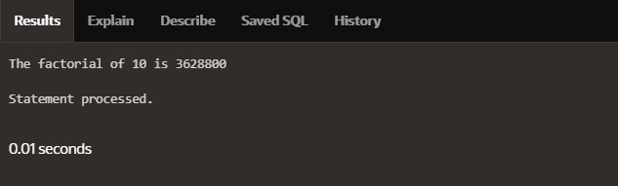

**Program2**

**Write a PL/SQL program using Procedures IN,INOUT,OUT parameters to retrieve thecorrespondingbook informationinlibrary**

**CREATEORREPLACEPROCEDUREbook_info(**

**p_book_id IN NUMBER,p_author OUT VARCHAR2,p_title OUT VARCHAR2,p_published_dateOUTDATE**

**) ASBEGIN**

**SELECT author, title, published_dateINTO p_author, p_title, p_published_dateFROMbooks**

**WHEREbook_id=p_book_id;**

**EXCEPTION**

**WHENNO_DATA_FOUNDTHEN**

**p_author := NULL;p_title:=NULL;**

**p_published_date := NULL;WHENOTHERS THEN**

**RAISE;**

**ENDbook_info;**

**DECLARE**

**v_author VARCHAR2(100);v_title VARCHAR2(100);v_published_date DATE;v_book_idNUMBER:=1;**

**BEGIN**

**book_info(v_book_id,v_author,v_title,v_published_date);**

**IF v_author IS NOT NULL THENDBMS_OUTPUT.PUT_LINE('Book ID: ' || v_book_id);DBMS_OUTPUT.PUT_LINE('Author: ' || v_author);DBMS_OUTPUT.PUT_LINE('Title:'||v_title);**

**DBMS_OUTPUT.PUT_LINE('Published Date: ' || TO_CHAR(v_published_date, 'YYYY-MM-DD'));**

**ELSE**

**DBMS_OUTPUT.PUT_LINE('No book found with ID: ' || v_book_id);END IF;**

**END;**

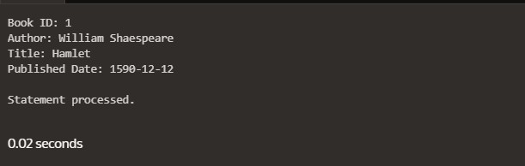

|  |  |  |
| --- | --- | --- |
| **Ex.No.: 13** | | **WORKING WITH TRIGGERS** |
| **Date:** | 20/09/2024 |

**Program1**

**WriteacodeinPL/SQLtodevelopatriggerthatenforcesreferentialintegritybypreventingthedeletionofaparentrecordifchildrecords exist.**

**CREATE OR REPLACE TRIGGER prevent_parent_deletionBEFOREDELETE ONemployees**

**FOR EACH ROWDECLARE**

**pl_dept_count NUMBER;BEGIN**

**SELECTCOUNT(*)**

**INTO pl_dept_countFROMdepartment**

**WHERE dept_id = :OLD.employee_id;IFpl_dept_count >0THEN**

**RAISE_APPLICATION_ERROR(-20001, 'Cannot delete employee record asdepartmentrecords exist.');**

**END IF;END;**

**DELETE FROM employeesWHEREemployee_id=70;**

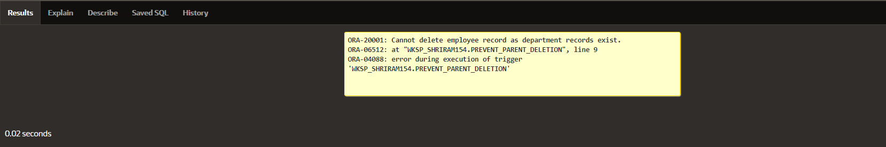

**Program2**

**WriteacodeinPL/SQLtocreateatriggerthatchecksforduplicatevaluesinaspecificcolumnand raisesanexception iffound.**

**CREATE OR REPLACE TRIGGER prevent_duplicate_manager_idBEFOREINSERTORUPDATE ONemployees**

**FOR EACH ROWDECLARE**

**pl_count NUMBER;BEGIN**

**SELECTCOUNT(*)**

**INTO pl_countFROMemployees**

**WHERE manager_id = :NEW.manager_idAND employee_id != :NEW.employee_id;IFpl_count>0THEN**

**RAISE_APPLICATION_ERROR(-20003,'Duplicatemanager_idfound:'||**

**:NEW.manager_id);ENDIF;**

**END;**

**INSERT INTO employees (employee_id, first_name, last_name, email, phone_number,hire_date,job_id,salary,commission_pct,manager_id,department_id)**

**VALUES (202, 'Jane', 'Smith','john006@gmail.com',7383922241,'11/9/2000','ST_CLERK',10000,0.15,400,80);**

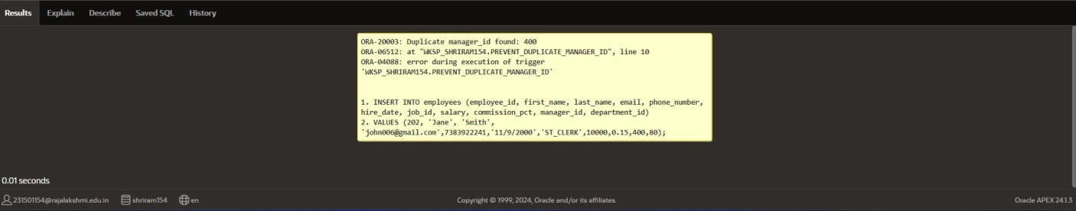

**Program3**

**WriteacodeinPL/SQLtocreateatriggerthatrestrictstheinsertionofnewrowsifthetotalofa**

**column'svaluesexceedsacertainthreshold.**

**CREATE OR REPLACE TRIGGER restrict_salary_insertionBEFOREINSERTONemployees**

**FOR EACH ROWDECLARE**

**total_salary NUMBER;thresholdNUMBER:=100000;**

**BEGIN**

**SELECT SUM(salary)INTO total_salaryFROMemployees;**

**IF(total_salary+:NEW.salary)>thresholdTHEN**

**RAISE_APPLICATION_ERROR(-20004, 'Insertion denied: Total salary exceeds thethresholdof'||threshold);**

**END IF;END;**

**INSERT INTO employees (employee_id, first_name, last_name, email, phone_number,hire_date,job_id,salary,commission_pct,manager_id,department_id)**

**VALUES (203, 'Charlie', 'Brown', 'charlie203@gmail.com', '9122334455','03/01/2021','#cb203',5000,0.20,1000,50);**

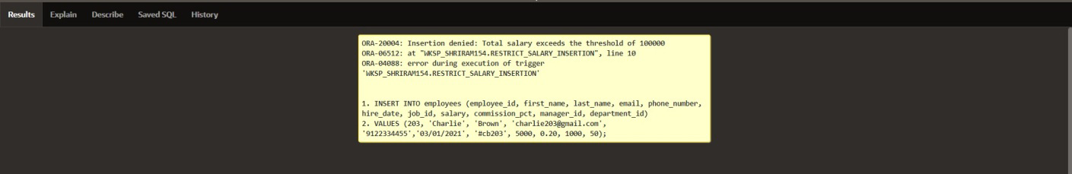

**PROGRAM 4**

**Write a code in PL/SQL to design a trigger that captures changes made to specificcolumnsand logstheminanaudittable.**

**CREATE OR REPLACE TRIGGER audit_changesAFTER UPDATE OF salary, job_id ON employeesFOREACH ROW**

**BEGIN**

**IF:OLD.salary!=:NEW.salaryOR:OLD.job_id!=:NEW.job_idTHENINSERTINTOemployee_audit (**

**employee_id,old_salary,new_salary,old_job_title,new_job_title,change_timestamp,changed_by**

**)VALUES (**

**:OLD.employee_id,**

**:OLD.salary,**

**:NEW.salary,**

**:OLD.job_id,**

**:NEW.job_id,SYSTIMESTAMP,USER**

**);ENDIF;**

**END;**

**UPDATEemployees**

**SET salary = 55000, job_id = 'ST_CLERK'WHEREemployee_id =176;**

**SELECT*FROMemployee_audit;**

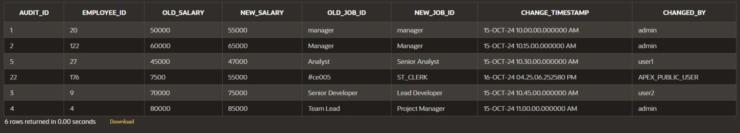

**PROGRAM 5**

**WriteacodeinPL/SQLtoimplementatriggerthatrecordsuseractivity(inserts,updates,deletes)inanauditlogfora givensetoftables.**

**CREATE OR REPLACE TRIGGER trg_audit_employeesAFTER INSERT OR UPDATE OR DELETE ON employeesFOREACH ROW**

**DECLARE**

**v_old_values CLOB;v_new_valuesCLOB;**

**BEGIN**

**IFINSERTINGTHEN**

**v_old_values:=NULL;**

**v_new_values := 'employee_id: ' || :NEW.employee_id || ', ' ||'first_name:'||:NEW.first_name||','||**

**'salary:'||:NEW.salary;**

**INSERT INTO audit_log (action, table_name, record_id, changed_by, new_values)VALUES('INSERT','employees',:NEW.employee_id,USER,v_new_values);**

**ELSIFUPDATINGTHEN**

**v_old_values := 'employee_id: ' || :OLD.employee_id || ', ' ||'first_name:'||:OLD.first_name||','||**

**'salary:'||:OLD.salary;**

**v_new_values := 'employee_id: ' || :NEW.employee_id || ', ' ||'first_name:'||:NEW.first_name||','||**

**'salary:'||:NEW.salary;**

**INSERT INTO audit_log (action, table_name, record_id, changed_by, old_values,new_values)**

**VALUES ('UPDATE', 'employees', :NEW.employee_id, USER, v_old_values,v_new_values);**

**ELSIFDELETINGTHEN**

**v_old_values := 'employee_id: ' || :OLD.employee_id || ', ' ||'first_name:'||:OLD.first_name||','||**

**'salary: ' || :OLD.salary;v_new_values:=NULL;**

**INSERT INTO audit_log (action, table_name, record_id, changed_by, old_values)VALUES('DELETE','employees',:OLD.employee_id,USER,v_old_values);**

**ENDIF;**

**ENDtrg_audit_employees;**

**INSERT INTO employees (employee_id, first_name, salary)VALUES(3,'Ball', 50000);**

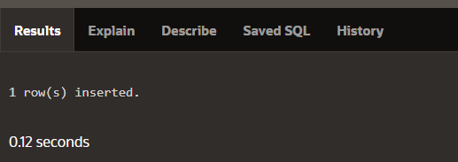

**UPDATE employeesSETsalary=55000**

**WHEREemployee_id=3;**

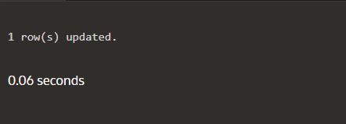

**DELETE FROM employeesWHEREemployee_id=3;**

**SELECT*FROMaudit_log;**

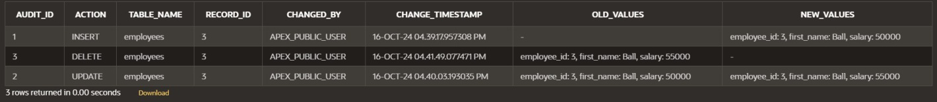

**PROGRAM 6**

**WriteacodeinPL/SQLtoimplementatriggerthatautomaticallycalculatesandupdatesarunning totalcolumnforatablewhenever new rowsareinserted.**

**CREATE TABLE transactions (transaction_id NUMBER PRIMARY KEY,amountNUMBER,**

**running_totalNUMBER**

**);**

**CREATE OR REPLACE TRIGGER update_running_totalFORINSERT ONtransactions**

**COMPOUNDTRIGGER**

**TYPEamount_arrayISTABLEOFNUMBERINDEXBYPLS_INTEGER;**

**new_amountsamount_array;**

**BEFORE EACH ROW ISBEGIN**

**new_amounts(:NEW.transaction_id) := :NEW.amount;ENDBEFORE EACH ROW;**

**AFTER STATEMENT ISBEGIN**

**DECLARE**

**v_total NUMBER;BEGIN**

**SELECT NVL(MAX(running_total), 0)INTOv_total**

**FROMtransactions;**

**FOR i IN new_amounts.FIRST .. new_amounts.LAST LOOPv_total:=v_total+new_amounts(i);**

**UPDATEtransactions**

**SET running_total = v_totalWHEREtransaction_id=i;**

**END LOOP;END;**

**ENDAFTERSTATEMENT;**

**ENDupdate_running_total;**

**INSERTINTOtransactions(transaction_id,amount)**

**VALUES(1,10000);**

**INSERT INTO transactions (transaction_id, amount)VALUES(2,20000);**

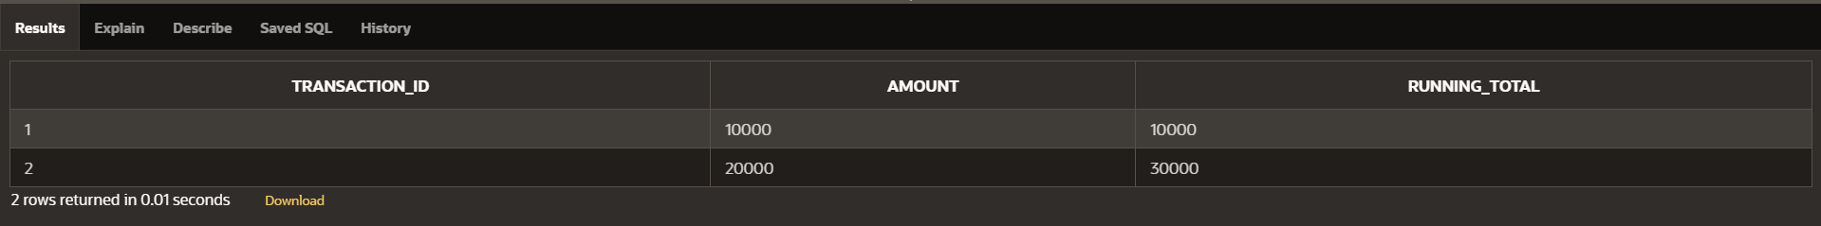

**PROGRAM 7**

**WriteacodeinPL/SQLtocreateatriggerthatvalidatestheavailabilityofitemsbeforeallowinganorder tobeplaced,consideringstocklevelsand pendingorders.**

**CREATETABLEinventory(item_idNUMBERPRIMARYKEY,**

**item_name VARCHAR2(100),stock_levelNUMBER**

**);**

**CREATETABLEorders(**

**order_id NUMBER PRIMARY KEY,item_idNUMBER,**

**quantity NUMBER,order_statusVARCHAR2(20),**

**CONSTRAINTfk_itemFOREIGNKEY(item_id)REFERENCESinventory(item_id)**

**);**

**CREATE OR REPLACE TRIGGER validate_stock_before_orderBEFOREINSERTONorders**

**FOR EACH ROWDECLARE**

**v_stock_level NUMBER;v_pending_ordersNUMBER;**

**BEGIN**

**SELECT stock_levelINTO v_stock_levelFROMinventory**

**WHERE item_id = :NEW.item_id;SELECT NVL(SUM(quantity), 0)INTOv_pending_orders**

**FROMorders**

**WHERE item_id = :NEW.item_idANDorder_status='Pending';**

**IF (:NEW.quantity + v_pending_orders) > v_stock_level THENRAISE_APPLICATION_ERROR(-20001,'Insufficientstockforitem:'||:NEW.item_id);**

**END IF;END;**

**INSERTINTOorders(order_id,item_id,quantity,order_status)VALUES(1,101, 5,'Pending');**

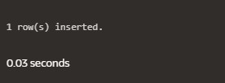

**INSERTINTOorders(order_id,item_id,quantity,order_status)VALUES(2,103, 20, 'Pending');**

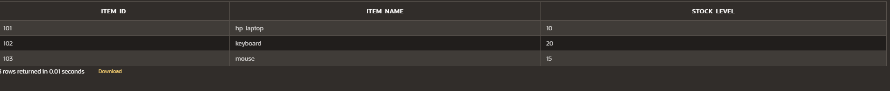



|  |  |  |
| --- | --- | --- |
| **Ex.No.: 14** | | **MONGO DB** |
| **Date:** | 26/09/2024 |

1. **WriteaMongoDBquerytofindtherestaurantId,name,boroughandcuisineforthoserestaurants which prepared dish except 'American' and 'Chinees' or restaurant's namebeginswithletter'Wil'.**

**db.restaurants.find(**

**{**

**$or:[**

**{cuisine:{$nin:["American","Chinees"]}},**

**{name:{$regex:/^Wil/i}}**

**]**

**},**

**{**

**restaurant_id:1,**

**name:1,**

**borough:1,**

**cuisine:1,**

**_id:0**

**}**

**);**

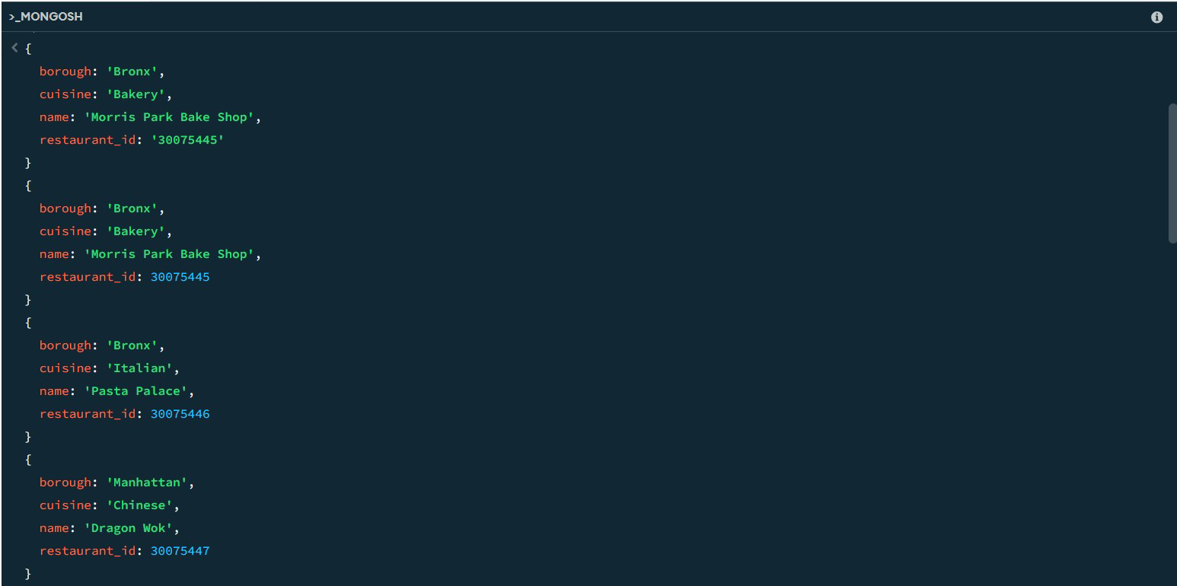

1. **Write a MongoDB query to find the restaurant Id, name, and grades for thoserestaurants which achieved a grade of "A" and scored 11 on an ISODate "2014-08-11T00:00:00Z"among manyofsurvey dates..**

**db.restaurants.find(**

**{**

**grades:{**

**$elemMatch: {grade: "A",score:11**

**}**

**}**

**},**

**{**

**restaurant_id:1,**

**name:1,**

**grades:1,**

**_id:0**

**}**

**);**

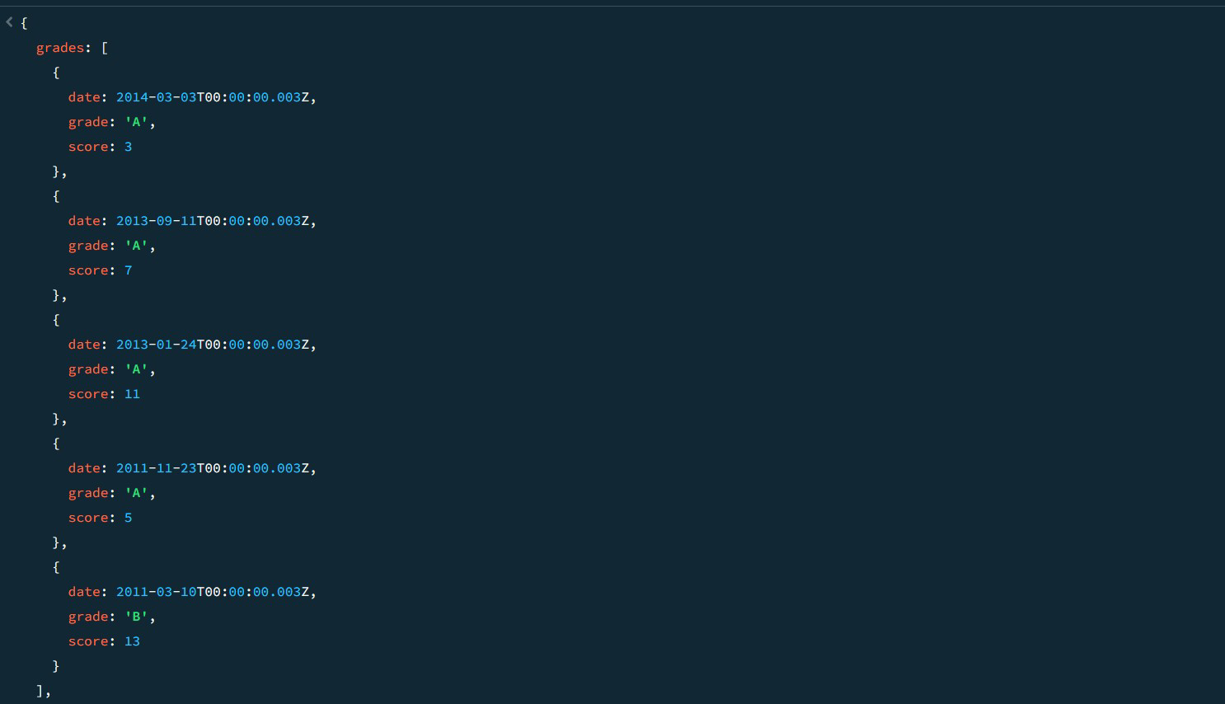

1. **Write a MongoDB query to find the restaurant Id, name and grades for thoserestaurants where the 2nd element of grades array contains a grade of "A" and score 9onanISODate"2014-08-11T00:00:00Z".**

**db.restaurants.find(**

**{**

**"grades.1":{**

**$elemMatch: {grade: "A",score:9**

**}**

**}**

**},**

**{**

**restaurant_id:1,**

**name:1,**

**grades:1,**

**_id:0**

**}**

**);**

1. **Write a MongoDB query to find the restaurant Id, name, address and geographicallocation for those restaurants where 2nd element of coord array contains a value whichismorethan42andupto52..**

**db.restaurants.find(**

**{**

**"address.coord.1":{$gt:42,$lte:52}**

**},**

**{**

**restaurant_id:1,**

**name:1,**

**address:1,**

**_id:0**

**}**

**);**

1. **Write a MongoDB query to arrange the name of the restaurants in ascending orderalongwithallthecolumns.**

**db.restaurants.find().sort({name:1});SAMPLEOUTPUT:-**

**{**

**_id:ObjectId('671b5e6d56ec9972ca8f5dc4'),address:{**

**building: 5566,coord:[**

**-73.867377,**

**40.854047**

**],**

**street: '28th Avenue',zipcode:10490**

**},**

**borough: 'Bronx',cuisine: 'BBQ',grades:[**

**{**

**date:2014-03-03T00:00:00.028Z,**

**grade: 'A',score:10**

**},**

**{**

**date:2013-09-11T00:00:00.028Z,**

**grade: 'A',score:7**

**},**

**{**

**date:2013-01-24T00:00:00.028Z,**

**grade: 'A',score:11**

**},**

**{**

**date:2011-11-23T00:00:00.028Z,**

**grade: 'A',score:9**

**},**

**{**

**date:2011-03-10T00:00:00.028Z,**

**grade:'B',**

**score:15**

**}**

**],**

**name: 'BBQ Haven',restaurant_id:30075473**

**}**

**{**

**_id:ObjectId('671b5dab56ec9972ca8f5db0'),address:{**

**building: 5566,coord:[**

**-73.859377,**

**40.850047**

**],**

**street: '8th Avenue',zipcode:10470**

**},**

**borough: 'Manhattan',cuisine: 'French',grades:[**

**{**

**date:2014-03-03T00:00:00.008Z,**

**grade: 'A',score:7**

**},**

**{**

**date:2013-09-11T00:00:00.008Z,**

**grade: 'A',score:9**

**},**

**{**

**date:2013-01-24T00:00:00.008Z,**

**grade: 'A',score:10**

**},**

**{**

**date:2011-11-23T00:00:00.008Z,**

**grade: 'B',score:15**

**},**

**{**

**date:2011-03-10T00:00:00.008Z,**

**grade: 'A',score:6**

**}**

**],**

**name: 'Bistro Belle',restaurant_id:30075453**

**}**

1. **Write a MongoDB query to arrange the name of the restaurants in descending alongwithallthecolumns.**

**db.restaurants.find().sort({name:-1});**

**SAMPLEOUTPUT**

**{**

**_id:ObjectId('671b5e9456ec9972ca8f5dc8'),address:{**

**building: 9900,coord:[**

**-73.868977,**

**40.854847**

**],**

**street: '32nd Avenue',zipcode:10494**

**},**

**borough: 'Manhattan',cuisine: 'Russian',grades:[**

**{**

**date:2014-03-03T00:00:00.032Z,**

**grade: 'A',score:10**

**},**

**{**

**date:2013-09-11T00:00:00.032Z,**

**grade: 'B',score:5**

**},**

**{**

**date:2013-01-24T00:00:00.032Z,**

**grade: 'A',score:9**

**},**

**{**

**date:2011-11-23T00:00:00.032Z,**

**grade: 'A',score:8**

**},**

**{**

**date:2011-03-10T00:00:00.032Z,**

**grade: 'A',score:11**

**}**

**],**

**name: "Tsar's Table",restaurant_id:30075477**

**}**

**{**

**_id:ObjectId('671b5e6d56ec9972ca8f5dbe'),address:{**

**building: 9900,coord:[**

**-73.864977,**

**40.852847**

**],**

**street: '22nd Avenue',zipcode:10484**

**},**

**borough: 'Bronx',cuisine: 'Italian',grades:[**

**{**

**date:2014-03-03T00:00:00.022Z,**

**grade: 'A',score:8**

**},**

**{**

**date:2013-09-11T00:00:00.022Z,**

**grade: 'B',score:5**

**},**

**{**

**date:2013-01-24T00:00:00.022Z,**

**grade: 'A',score:12**

**},**

**{**

**date:2011-11-23T00:00:00.022Z,**

**grade: 'A',score:9**

**},**

**{**

**date:2011-03-10T00:00:00.022Z,**

**grade: 'A',score:14**

**}**

**],**

**name: 'Trattoria Bella',restaurant_id:30075467**

**}**

1. **WriteaMongoDBquerytoarrangethenameofthecuisineinascendingorderandforthatsamecuisine borough shouldbeindescending order.**

**db.restaurants.find().sort({ cuisine: 1, borough: -1 });SAMPLEOUTPUT:-**

**{**

**_id:ObjectId('671b5d549d3d63480e0a64e9'),address:{**

**building: 2233,coord:[**

**-73.858177,**

**40.849447**

**],**

**street: '5th Avenue',zipcode:10467**

**},**

**borough: 'Bronx',cuisine:'American',**

**grades:[**

**{**

**date:2014-03-03T00:00:00.005Z,**

**grade: 'A',score:10**

**},**

**{**

**date:2013-09-11T00:00:00.005Z,**

**grade: 'A',score:6**

**},**

**{**

**date:2013-01-24T00:00:00.005Z,**

**grade: 'B',score:12**

**},**

**{**

**date:2011-11-23T00:00:00.005Z,**

**grade: 'A',score:9**

**},**

**{**

**date:2011-03-10T00:00:00.005Z,**

**grade: 'A',score:14**

**}**

**],**

**name: 'Burger Bistro',restaurant_id:30075450**

**}**

**{**

**_id:ObjectId('671b5e6d56ec9972ca8f5dc4'),address:{**

**building: 5566,coord:[**

**-73.867377,**

**40.854047**

**],**

**street: '28th Avenue',zipcode:10490**

**},**

**borough: 'Bronx',cuisine:'BBQ',**

**grades:[**

**{**

**date:2014-03-03T00:00:00.028Z,**

**grade: 'A',score:10**

**},**

**{**

**date:2013-09-11T00:00:00.028Z,**

**grade: 'A',score:7**

**},**

**{**

**date:2013-01-24T00:00:00.028Z,**

**grade: 'A',score:11**

**},**

**{**

**date:2011-11-23T00:00:00.028Z,**

**grade: 'A',score:9**

**},**

**{**

**date:2011-03-10T00:00:00.028Z,**

**grade: 'B',score:15**

**}**

**],**

**name: 'BBQ Haven',restaurant_id:30075473**

**}**

1. **WriteaMongoDBquerytoknowwhetheralltheaddressescontainsthestreetornot.**

**db.restaurants.find(**

**{**

**"address.street":{$exists:false}**

**}**

**);**

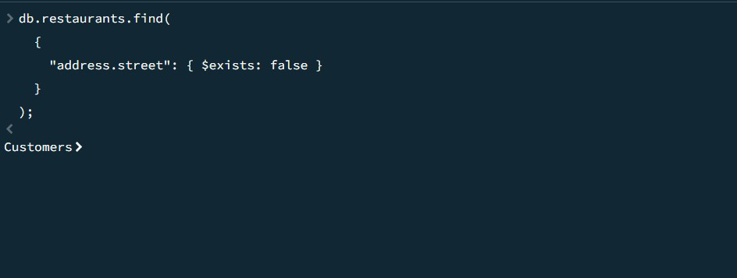

1. **Write a MongoDB query which will select all documents in the restaurants collectionwherethecoord fieldvalue isDouble.**

**db.restaurants.find(**

**{**

**"address.coord":{$type:"double"}**

**}**

**);**

**SAMPLEOUTPUT:-**

**{**

**_id:ObjectId('671b92d339ec8a9bc8b6588b'),address:{**

**building: '1007',coord:[**

**-73.856077,**

**40.848447**

**],**

**street: 'Morris Park Ave',zipcode:'10462'**

**},**

**borough: 'Bronx',cuisine: 'Bakery',grades:[**

**{**

**date:2014-03-03T00:00:00.000Z,**

**grade: 'A',score:2**

**},**

**{**

**date:2013-09-11T00:00:00.000Z,**

**grade: 'A',score:6**

**},**

**{**

**date:2013-01-24T00:00:00.000Z,**

**grade: 'A',score:10**

**},**

**{**

**date:2011-11-23T00:00:00.000Z,**

**grade: 'A',score:9**

**},**

**{**

**date:2011-03-10T00:00:00.000Z,**

**grade: 'B',score:14**

**}**

**],**

**name: 'Morris Park Bake Shop',restaurant_id:'30075445'**

**}**

**{**

**_id:ObjectId('671b5d549d3d63480e0a64e5'),address:{**

**building: 1234,coord:[**

**-73.856577,**

**40.848647**

**],**

**street: '1st Avenue',zipcode:10463**

**},**

**borough: 'Bronx',cuisine: 'Italian',grades:[**

**{**

**date:2014-03-03T00:00:00.001Z,**

**grade: 'A',score:5**

**},**

**{**

**date:2013-09-11T00:00:00.001Z,**

**grade: 'A',score:8**

**},**

**{**

**date:2013-01-24T00:00:00.001Z,**

**grade: 'B',score:12**

**},**

**{**

**date:2011-11-23T00:00:00.001Z,**

**grade: 'A',score:7**

**},**

**{**

**date:2011-03-10T00:00:00.001Z,**

**grade: 'A',score:15**

**}**

**],**

**name: 'Pasta Palace',restaurant_id:30075446**

**}**

1. **Write a MongoDB query which will select the restaurant Id, name and grades forthose**

**restaurantswhichreturns0asaremainderafterdividingthescoreby7.**

**db.restaurants.find(**

**{**

**"grades.score":{$mod:[7,0]}**

**},**

**{**

**restaurant_id:1,**

**name:1,**

**grades:1,**

**_id:0**

**}**

**);**

**SAMPLEOUTPUT:-**

**{**

**grades:[**

**{**

**date:2014-03-03T00:00:00.000Z,**

**grade: 'A',score:2**

**},**

**{**

**date:2013-09-11T00:00:00.000Z,**

**grade: 'A',score:6**

**},**

**{**

**date:2013-01-24T00:00:00.000Z,**

**grade: 'A',score:10**

**},**

**{**

**date:2011-11-23T00:00:00.000Z,**

**grade: 'A',score:9**

**},**

**{**

**date:2011-03-10T00:00:00.000Z,**

**grade: 'B',score:14**

**}**

**],**

**name: 'Morris Park Bake Shop',restaurant_id:'30075445'**

**}**

**{**

**grades:[**

**{**

**date:2014-03-03T00:00:00.001Z,**

**grade: 'A',score:5**

**},**

**{**

**date:2013-09-11T00:00:00.001Z,**

**grade: 'A',score:8**

**},**

**{**

**date:2013-01-24T00:00:00.001Z,**

**grade: 'B',score:12**

**},**

**{**

**date:2011-11-23T00:00:00.001Z,**

**grade: 'A',score:7**

**},**

**{**

**date:2011-03-10T00:00:00.001Z,**

**grade: 'A',score:15**

**}**

**],**

**name: 'Pasta Palace',restaurant_id:30075446**

**}**

1. **Write a MongoDB query to find the restaurant name, borough, longitude and attitudeand cuisine for those restaurants which contains 'mon' as three letters somewhere in itsname.**

**db.restaurants.find(**

**{**

**name:{$regex:/mon/i}**

**},**

**{**

**name:1,**

**borough:1,**

**"address.coord.0": 1, // Longitude"address.coord.1": 1, // Latitudecuisine:1,**

**_id:0**

**}**

**);**

1. **Write a MongoDB query to find the restaurant name, borough, longitude and latitudeandcuisineforthoserestaurantswhichcontain'Mad'asfirstthreelettersofitsname.**

**db.restaurants.find(**

**{**

**name:{$regex:/^Mad/i}**

**},**

**{**

**name:1,**

**borough:1,**

**"address.coord.0": 1, // Longitude"address.coord.1": 1, // Latitudecuisine:1,**

**_id:0**

**}**

**);**

1. **Write a MongoDB query to find the restaurants that have at least one grade with ascoreoflessthan5.**

**db.restaurants.find(**

**{**

**"grades.score":{$lt:5}**

**}**

**);**

**SAMPLEOUTPUT:-**

**{**

**_id:ObjectId('671b92d339ec8a9bc8b6588b'),address:{**

**building:'1007',**

**coord:[**

**-73.856077,**

**40.848447**

**],**

**street: 'Morris Park Ave',zipcode:'10462'**

**},**

**borough: 'Bronx',cuisine: 'Bakery',grades:[**

**{**

**date:2014-03-03T00:00:00.000Z,**

**grade: 'A',score:2**

**},**

**{**

**date:2013-09-11T00:00:00.000Z,**

**grade: 'A',score:6**

**},**

**{**

**date:2013-01-24T00:00:00.000Z,**

**grade: 'A',score:10**

**},**

**{**

**date:2011-11-23T00:00:00.000Z,**

**grade: 'A',score:9**

**},**

**{**

**date:2011-03-10T00:00:00.000Z,**

**grade: 'B',score:14**

**}**

**],**

**name: 'Morris Park Bake Shop',restaurant_id:'30075445'**

**}**

**{**

**_id:ObjectId('671b5d549d3d63480e0a64e6'),address:{**

**building: 5678,coord:[**

**-73.856977,**

**40.848847**

**],**

**street: '2nd Avenue',zipcode:10464**

**},**

**borough: 'Manhattan',cuisine: 'Chinese',grades:[**

**{**

**date:2014-03-03T00:00:00.002Z,**

**grade: 'B',score:4**

**},**

**{**

**date:2013-09-11T00:00:00.002Z,**

**grade: 'A',score:9**

**},**

**{**

**date:2013-01-24T00:00:00.002Z,**

**grade: 'A',score:10**

**},**

**{**

**date:2011-11-23T00:00:00.002Z,**

**grade: 'A',score:8**

**},**

**{**

**date:2011-03-10T00:00:00.002Z,**

**grade: 'B',score:16**

**}**

**],**

**name: 'Dragon Wok',restaurant_id:30075447**

**}**

1. **Write a MongoDB query to find the restaurants that have at least one grade with ascoreoflessthan5and thatarelocatedintheborough ofManhattan.**

**db.restaurants.find(**

**{**

**"grades.score": { $lt: 5 },borough:"Manhattan"**

**}**

**);**

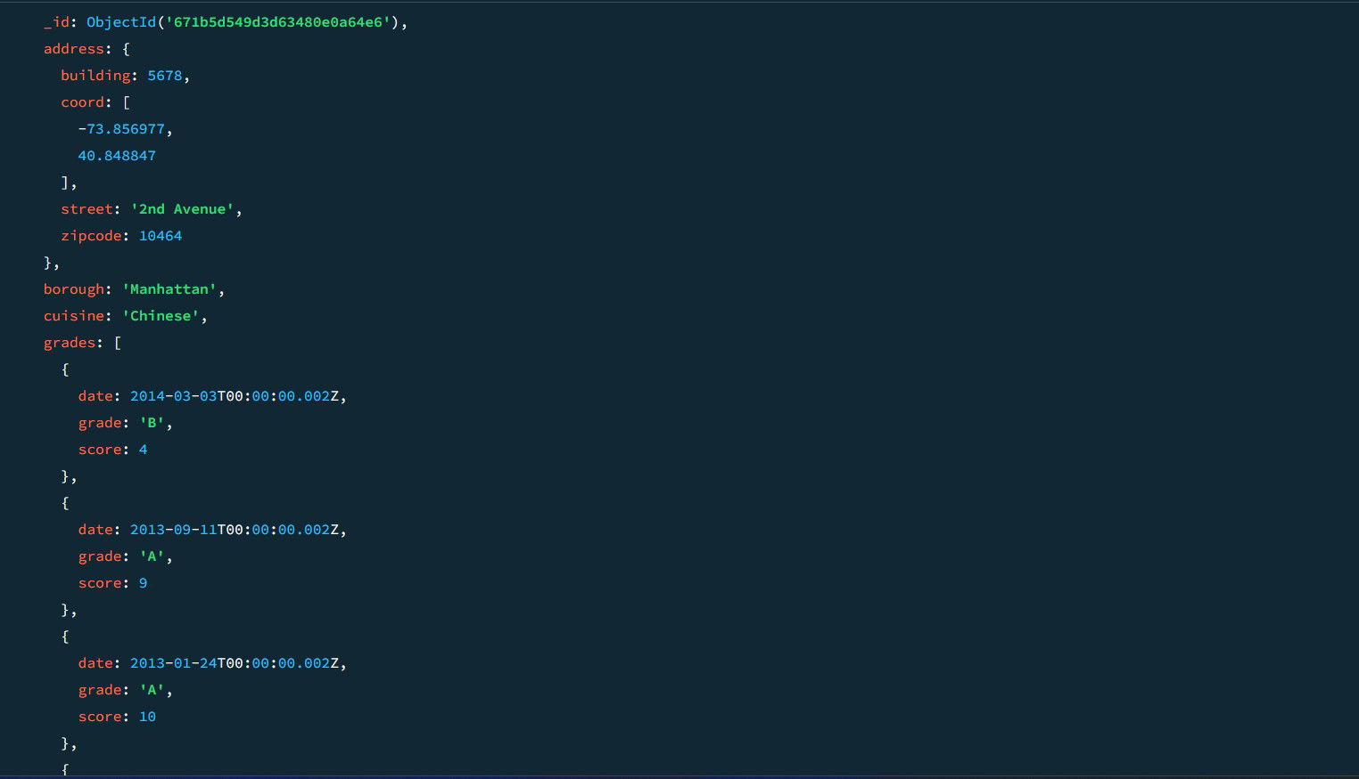

1. **Write a MongoDB query to find the restaurants that have at least one grade with ascoreoflessthan5andthatarelocatedintheboroughofManhattanorBrooklyn.**

**db.restaurants.find(**

**{**

**"grades.score":{$lt:5},**

**borough:{$in:["Manhattan","Brooklyn"]}**

**}**

**);**

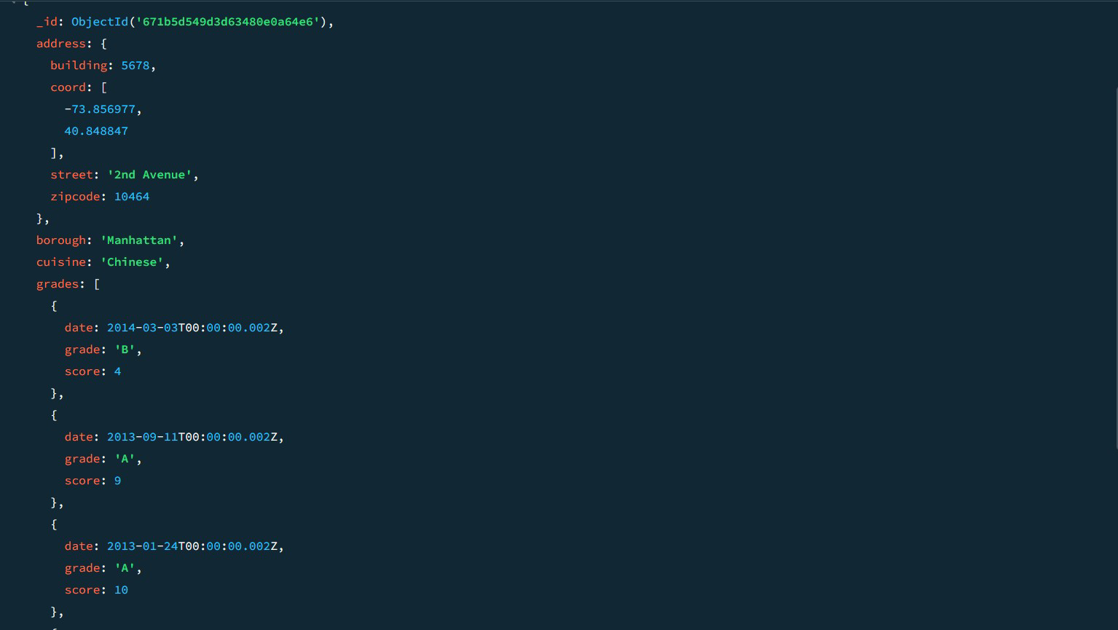

1. **Write a MongoDB query to find the restaurants that have at least one grade with ascoreoflessthan5andthatarelocatedintheboroughofManhattanorBrooklyn,andtheircuisine is notAmerican.**

**db.restaurants.find(**

**{**

**"grades.score":{$lt:5},**

**borough: { $in: ["Manhattan", "Brooklyn"] },cuisine:{$ne:"American" }**

**}**

**);**

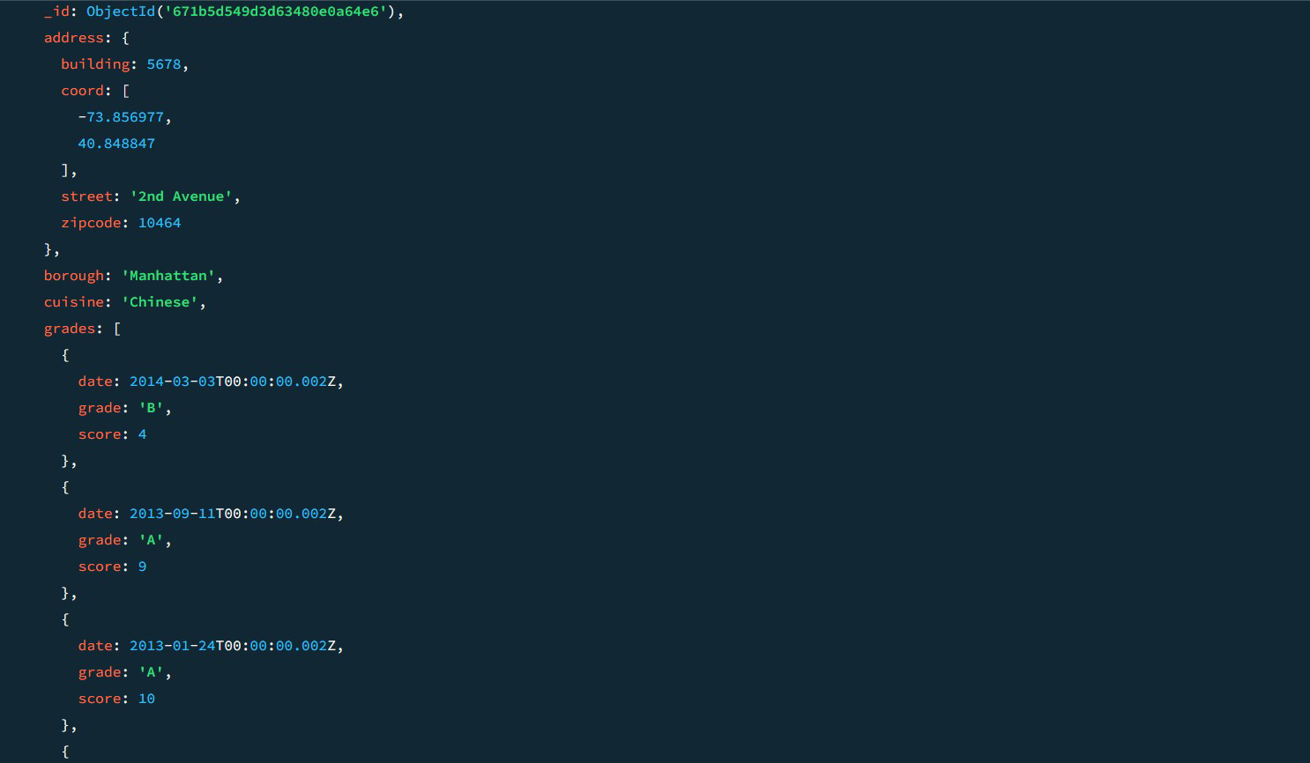

1. **Write a MongoDB query to find the restaurants that have at least one grade with ascoreoflessthan5andthatarelocatedintheboroughofManhattanorBrooklyn,andtheircuisine is notAmericanorChinese.**

**db.restaurants.find(**

**{**

**"grades.score":{$lt:5},**

**borough: { $in: ["Manhattan", "Brooklyn"] },cuisine:{$nin:["American","Chinese"]}**

**}**

**);**

1. **Write a MongoDB query to find the restaurants that have a grade with a score of 2 andagrade withascore of6.**

**db.restaurants.find(**

**{**

**grades:{**

**$all:[**

**{$elemMatch:{score: 2}},**

**{$elemMatch:{score: 6}}**

**]**

**}**

**}**

**);**

**SAMPLEOUTPUT:-**

**{**

**_id:ObjectId('671b92d339ec8a9bc8b6588b'),address:{**

**building: '1007',coord:[**

**-73.856077,**

**40.848447**

**],**

**street: 'Morris Park Ave',zipcode:'10462'**

**},**

**borough: 'Bronx',cuisine: 'Bakery',grades:[**

**{**

**date:2014-03-03T00:00:00.000Z,**

**grade: 'A',score:2**

**},**

**{**

**date:2013-09-11T00:00:00.000Z,**

**grade: 'A',score:6**

**},**

**{**

**date:2013-01-24T00:00:00.000Z,**

**grade: 'A',score:10**

**},**

**{**

**date:2011-11-23T00:00:00.000Z,**

**grade: 'A',score:9**

**},**

**{**

**date:2011-03-10T00:00:00.000Z,**

**grade: 'B',score:14**

**}**

**],**

**name: 'Morris Park Bake Shop',restaurant_id:'30075445'**

**}**

**{**

**_id:ObjectId('671b5c5f9d3d63480e0a64e4'),address:{**

**building: 1007,coord:[**

**-73.856077,**

**40.848447**

**],**

**street: 'Morris Park Ave',zipcode:10462**

**},**

**borough: 'Bronx',cuisine: 'Bakery',grades:[**

**{**

**date:2014-03-03T00:00:00.000Z,**

**grade: 'A',score:2**

**},**

**{**

**date:2013-09-11T00:00:00.000Z,**

**grade: 'A',score:6**

**},**

**{**

**date:2013-01-24T00:00:00.000Z,**

**grade: 'A',score:10**

**},**

**{**

**date:2011-11-23T00:00:00.000Z,**

**grade: 'A',score:9**

**},**

**{**

**date:2011-03-10T00:00:00.000Z,**

**grade: 'B',score:14**

**}**

**],**

**name: 'Morris Park Bake Shop',restaurant_id:30075445**

**}**

1. **Write a MongoDB query to find the restaurants that have a grade with a score of 2 andagrade withascore of6andarelocatedintheborough ofManhattan.**

**db.restaurants.find(**

**{**

**borough: "Manhattan",grades:{**

**$all:[**

**{$elemMatch:{score: 2}},**

**{$elemMatch:{score: 6}}**

**]**

**}**

**}**

**);**

1. **Write a MongoDB query to find the restaurants that have a grade with a score of 2 andagradewithascore of6andarelocatedintheborough ofManhattanorBrooklyn.**

**db.restaurants.find(**

**{**

**borough: { $in: ["Manhattan", "Brooklyn"] },grades:{**

**$all:[**

**{$elemMatch:{score: 2}},**

**{$elemMatch:{score: 6}}**

**]**

**}**

**}**

**);**

1. **Write a MongoDB query to find the restaurants that have a grade with a score of 2 anda grade with a score of 6 and are located in the borough of Manhattan or Brooklyn, andtheircuisine is notAmerican.**

**db.restaurants.find(**

**{**

**borough: { $in: ["Manhattan", "Brooklyn"] },grades:{**

**$all:[**

**{$elemMatch:{score: 2}},**

**{$elemMatch:{score: 6}}**

**]**

**},**

**cuisine:{$ne:"American"}**

**}**

**);**

1. **Write a MongoDB query to find the restaurants that have a grade with a score of 2 anda grade with a score of 6 and are located in the borough of Manhattan or Brooklyn, andtheircuisine is notAmericanorChinese.**

**db.restaurants.find(**

**{**

**borough: { $in: ["Manhattan", "Brooklyn"] },grades:{**

**$all:[**

**{$elemMatch:{score: 2}},**

**{$elemMatch:{score: 6}}**

**]**

**},**

**cuisine:{$nin:["American","Chinese"]}**

**}**

**);**

1. **Write a MongoDB query to find the restaurants that have a grade with a score of 2 oragrade withascore of6.**

**db.restaurants.find(**

**{**

**$or:[**

**{"grades.score":2},**

**{"grades.score":6}**

**]**

**}**

**);**

**SAMPLEOUTPUT:-**

**{**

**_id:ObjectId('671b5d549d3d63480e0a64e9'),address:{**

**building: 2233,coord:[**

**-73.858177,**

**40.849447**

**],**

**street: '5th Avenue',zipcode:10467**

**},**

**borough: 'Bronx',cuisine: 'American',grades:[**

**{**

**date:2014-03-03T00:00:00.005Z,**

**grade: 'A',score:10**

**},**

**{**

**date:2013-09-11T00:00:00.005Z,**

**grade: 'A',score:6**

**},**

**{**

**date:2013-01-24T00:00:00.005Z,**

**grade: 'B',score:12**

**},**

**{**

**date:2011-11-23T00:00:00.005Z,**

**grade: 'A',score:9**

**},**

**{**

**date:2011-03-10T00:00:00.005Z,**

**grade: 'A',score:14**

**}**

**],**

**name: 'Burger Bistro',restaurant_id:30075450**

**}**

**{**

**_id:ObjectId('671b5dab56ec9972ca8f5daf'),address:{**

**building: 4455,coord:[**

**-73.858977,**

**40.849847**

**],**

**street: '7th Avenue',zipcode:10469**

**},**

**borough: 'Bronx',cuisine: 'Thai',grades:[**

**{**

**date:2014-03-03T00:00:00.007Z,**

**grade: 'A',score:9**

**},**

**{**

**date:2013-09-11T00:00:00.007Z,**

**grade: 'B',score:6**

**},**

**{**

**date:2013-01-24T00:00:00.007Z,**

**grade: 'A',score:12**

**},**

**{**

**date:2011-11-23T00:00:00.007Z,**

**grade: 'A',score:8**

**},**

**{**

**date:2011-03-10T00:00:00.007Z,**

**grade: 'B',score:14**

**}**

**],**

**name: 'Thai Delight',restaurant_id:30075452**

**}**

**MOVIESCOLLECTION**

1. **Findallmovieswithfullinformationfromthe'movies'collectionthatreleasedintheyear**

**1893.**

**db.movies.find({year:1893});**

1. **Findallmovieswithfullinformationfromthe'movies'collectionthathavearuntimegreater**

**than120minutes.**

**db.movies.find({runtime:{$gt:120}});SAMPLEOUTPUT:-**

**{**

**_id:ObjectId('573a1390f29313caabcd42ec'),**

**plot:'AnastronautstrandedonMarsmustsurvivealone.',genres:[**

**'Sci-Fi','Drama'**

**],**

**runtime: 135,cast:[**

**'Matt Damon','JessicaChastain'**

**],**

**poster: 'https://m.media-amazon.com/images/poster4.jpg',title:'MarsAlone',**

**fullplot:'Anastronaut,leftaloneonMars,strugglestosurvivewith**

**limited resources while awaiting rescue.',languages:[**

**'English'**

**],**

**released:2015-10-02T00:00:00.000Z,**

**directors: ['RidleyScott'**

**],**

**rated: 'PG-13',awards: {wins:8,**

**nominations:6,**

**text:'8wins&6nominations.'**

**},**

**lastupdated:'2021-08-0917:22:30.000000000',**

**year: 2015,imdb: {rating:8,**

**votes:25650,**

**id:443**

**},**

**countries:['USA'**

**],**

**type: 'movie',tomatoes: {viewer:{**

**rating:4.5,**

**numReviews:2201,**

**meter:93**

**},**

**fresh: 18,critic: {rating:8.5,**

**numReviews:25,**

**meter:96**

**},**

**rotten:1,**

**lastUpdated:2021-07-19T21:20:55.000Z**

**}**

**}**

1. **Findallmovieswithfullinformationfromthe'movies'collectionthathave"Short" genre.**

**db.movies.find({ genres: "Short" });SAMPLEOUTPUT:-**

**{**

**_id:ObjectId('573a1390f29313caabcd42e8'),**

**plot:'Agroupofbanditsstageabrazentrainhold-up,onlytofinda**

**determined posse hot on their heels.',genres:[**

**'Short','Western'**

**],**

**runtime:11,cast:[**

**'A.C.Abadie',**

**"Gilbert M. 'Broncho Billy' Anderson",'GeorgeBarnes',**

**'JustusD.Barnes'**

**],**

**poster: 'https://m.media-amazon.com/images/M/MV5BMTU3NjE5NzYtYTYyNS00MDVmLWIwYjgtMmYwYWIxZDYyNzU2XkEyXkFqcGdeQXVyNzQzNzQxNzI@._V1_SY1000_SX677_AL_.jpg',**

**title:'TheGreatTrainRobbery',**

**fullplot: "Among the earliest existing films in American cinema -notable as the first film that presented a narrative story to tell - itdepictsagroupofcowboyoutlawswhoholdupatrainandrobthe**

**passengers.TheyarethenpursuedbyaSheriff'sposse.Severalsceneshavecolorincluded-allhandtinted.",**

**languages: ['English'**

**],**

**released:1903-12-01T00:00:00.000Z,**

**directors:['EdwinS.Porter'**

**],**

**rated: 'TV-G',awards: {wins:1,**

**nominations:0,**

**text:'1win.'**

**},**

**lastupdated:'2015-08-1300:27:59.177000000',**

**year: 1903,imdb: {rating:7.4,**

**votes:9847,**

**id:439**

**},**

**countries:['USA'**

**],**

**type: 'movie',tomatoes: {viewer:{**

**rating:3.7,**

**numReviews:2559,**

**meter:75**

**},**

**fresh: 6,critic: {rating:7.6,**

**numReviews:6,**

**meter:100**

**},**

**rotten:0,**

**lastUpdated:2015-08-08T19:16:10.000Z**

**}**

**}**

1. **Retrieve all movies from the 'movies' collection that were directedby "William K.L. Dickson"and include complete information for eachmovie.**

**db.movies.find({directors:"WilliamK.L.Dickson"});**

1. **Retrieveallmoviesfromthe'movies'collectionthatwerereleasedintheUSAandincludecompleteinformationforeachmovie.**

**db.movies.find({countries:"USA"});**

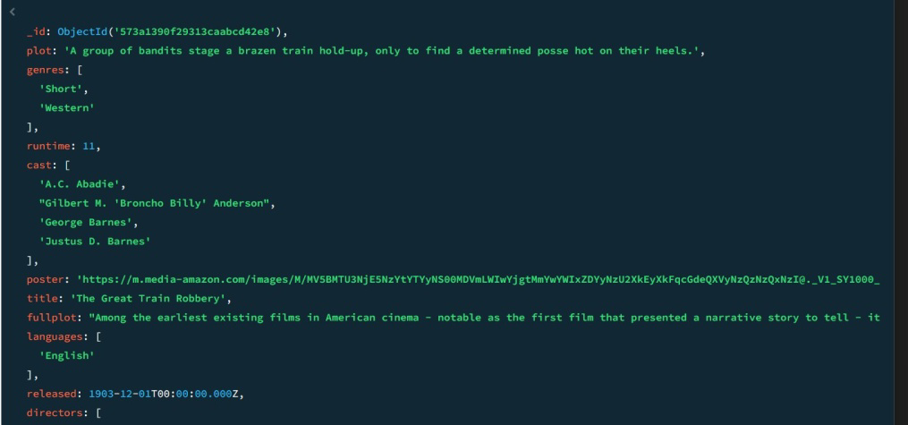

1. **Retrieveallmoviesfromthe'movies'collectionthathavecompleteinformationandarerated**

**as"UNRATED".**

**db.movies.find({rated:"UNRATED"});**

1. **Retrieveallmoviesfromthe'movies'collectionthathavecompleteinformationandhavereceivedmorethan1000votesonIMDb.**

**db.movies.find({"imdb.votes":{$gt:1000}});**

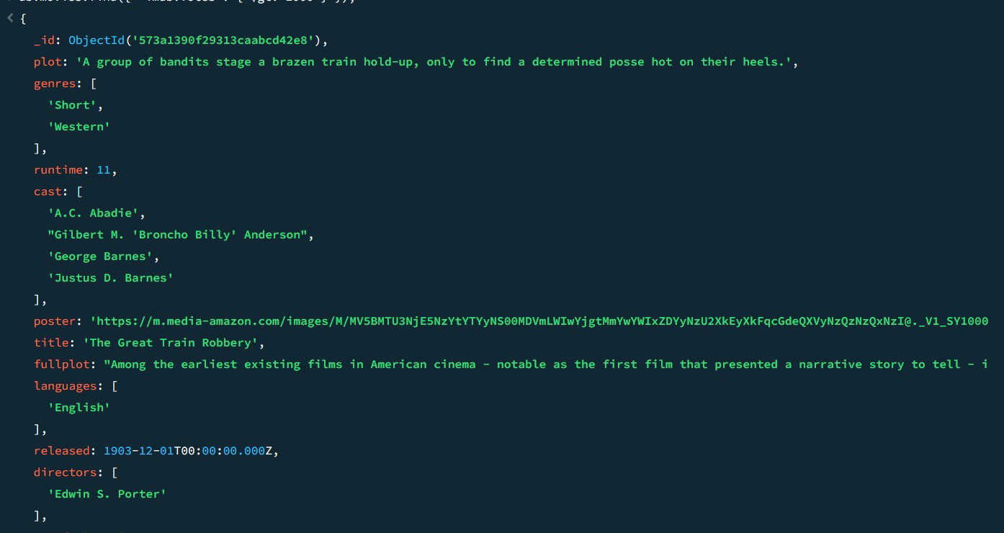

1. **Retrieveallmoviesfromthe'movies'collectionthathavecompleteinformationandhaveanIMDb ratinghigherthan7.**

**db.movies.find({"imdb.rating":{$gt:7}});**

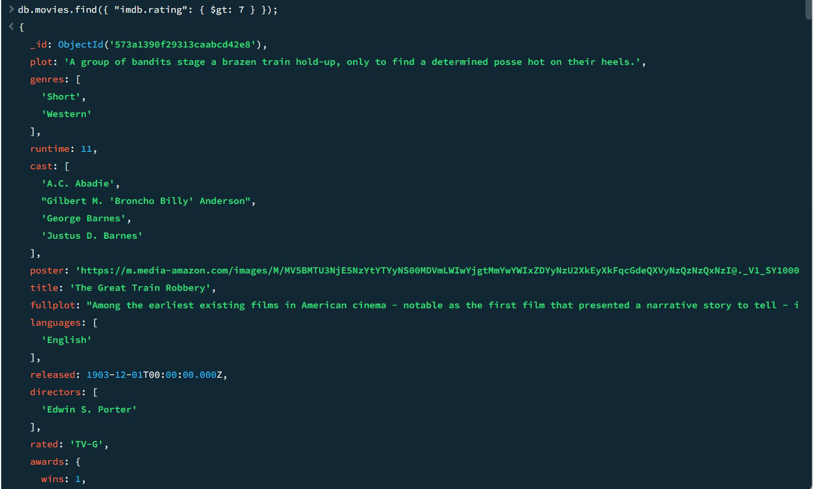

1. **Retrieve all movies from the 'movies' collection that havecompleteinformationandhaveaviewerratinghigherthan4onTomatoes.**

**db.movies.find({"tomatoes.viewer.rating":{$gt:4}});**

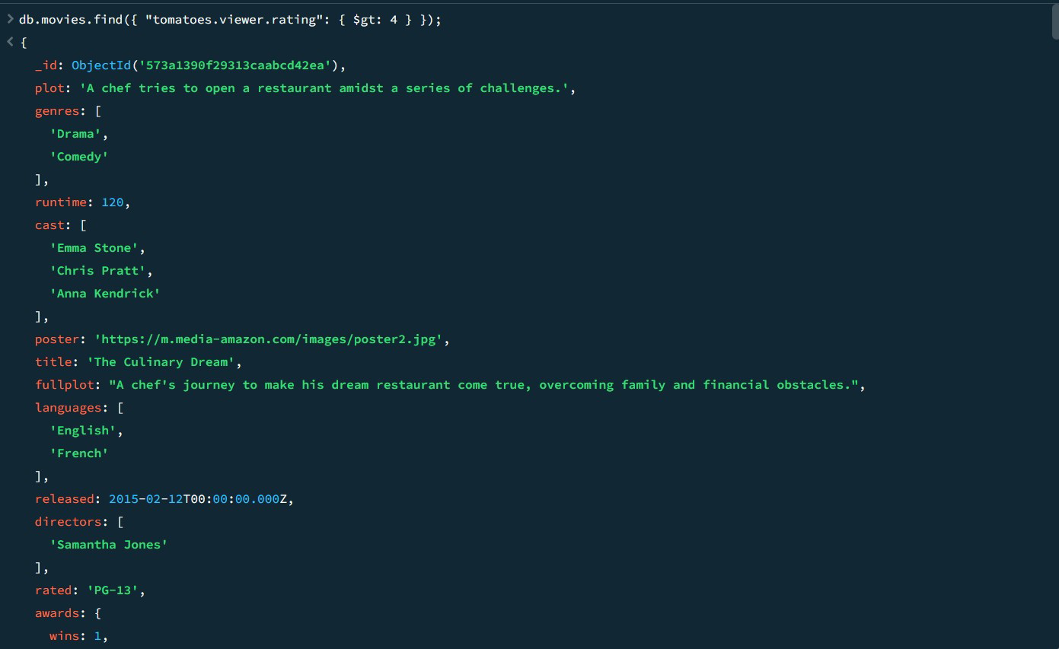

1. **Retrieveallmoviesfromthe'movies'collectionthathavereceivedanaward.**

**db.movies.find({"awards.wins":{$gt:0}});**

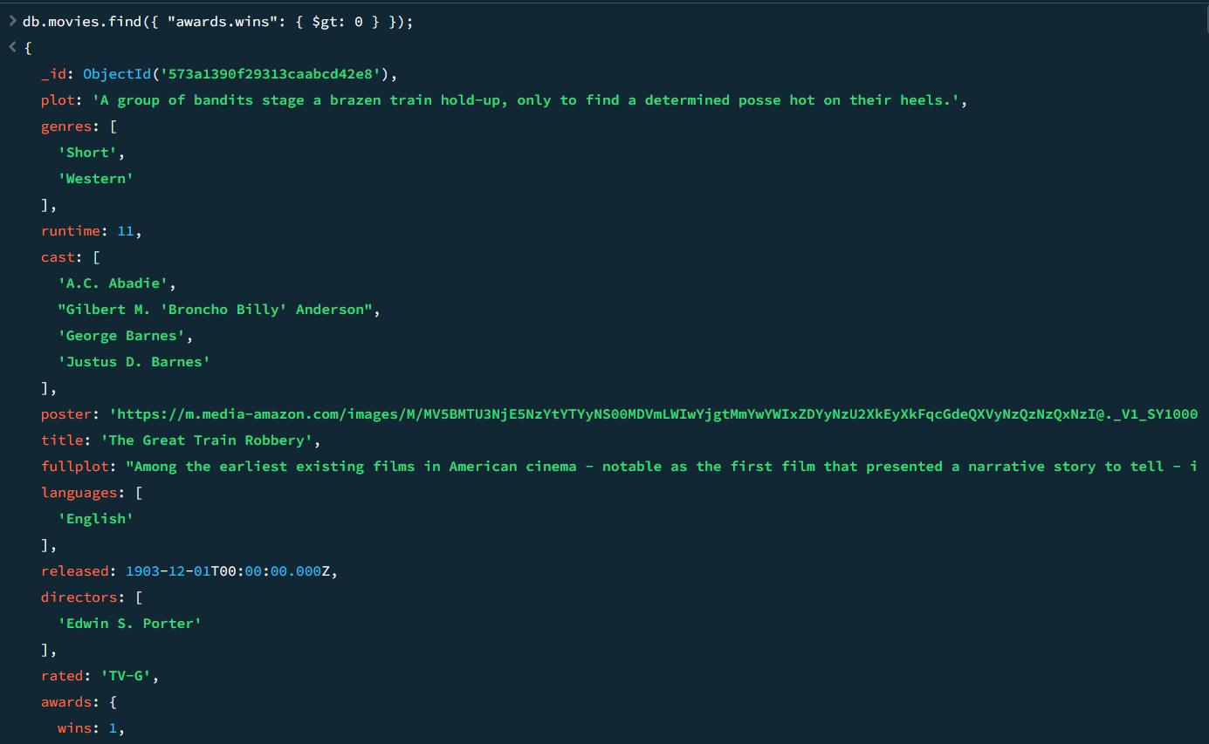

1. **Findallmovieswithtitle,languages,released,directors,writers,awards, year, genres, runtime, cast, countries from the 'movies'collectioninMongoDBthathaveatleastonenomination.**

**db.movies.find(**

**{"awards.nominations":{$gt:0}},**

**{**

**title:1,**

**languages:1,**

**released:1,**

**directors:1,**

**writers:1,**

**awards:1,**

**year:1,**

**genres:1,**

**runtime:1,**

**cast:1,**

**countries:1**

**}**

**);**

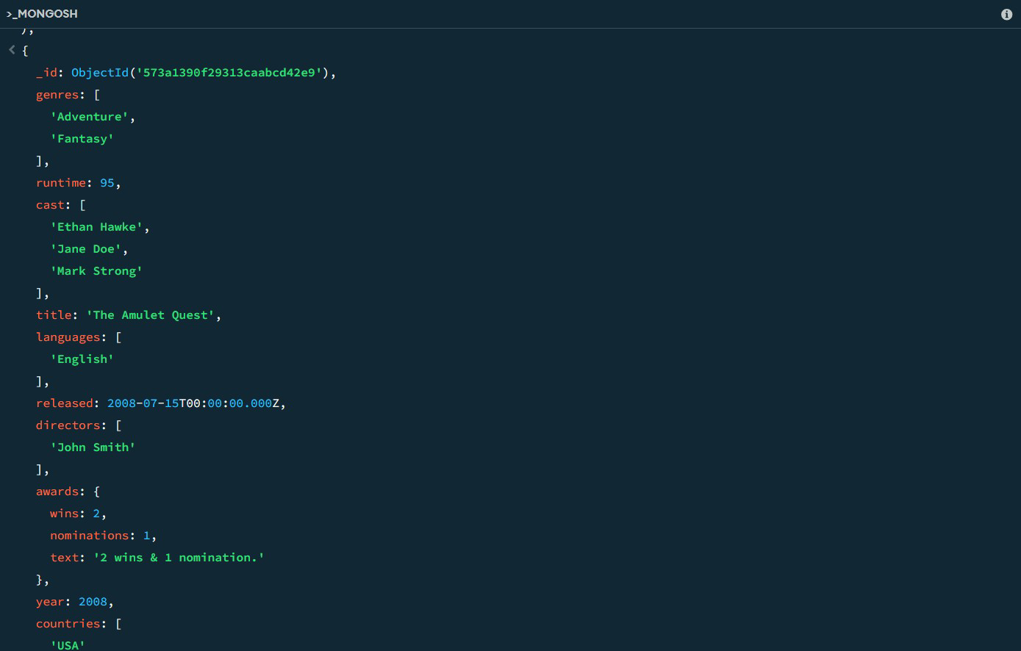

1. **Findallmovieswithtitle,languages,released,directors,writers,awards, year, genres, runtime, cast, countries from the 'movies'collectioninMongoDBwithcastincluding"CharlesKayser".**

**db.movies.find(**

**{cast:"CharlesKayser"},**

**{**

**title:1,**

**languages:1,**

**released:1,**

**directors:1,**

**writers:1,**

**awards:1,**

**year:1,**

**genres:1,**

**runtime:1,**

**cast:1,**

**countries:1**

**}**

**);**

1. **Retrieve all movies with title, languages, released, directors,writers, countries from the 'movies' collection in MongoDB thatreleasedonMay9,1893.**

**db.movies.find(**

**{released:ISODate("1893-05-09T00:00:00Z")},**

**{**

**title:1,**

**languages:1,**

**released:1,**

**directors:1,**

**writers:1,**

**countries:1**

**}**

**);**

1. **Retrieve all movies with title, languages, released, directors,writers,countriesfromthe'movies'collectioninMongoDBthathaveaword"scene"inthetitle.**

**db.movies.find(**

**{title:{$regex:/scene/i}},**

**{**

**title:1,**

**languages:1,**

**released:1,**

**directors:1,**

**writers:1,**

**countries:1**

**}**

**);**

|  |  |  |
| --- | --- | --- |
| **Ex.No.: 15** | | **OTHER DATABASE OBJECTS** |
| **Date:** | 27/09/2024 |

* 1. **Create a sequence to be used with the primary key column of the DEPT table. Thesequence should start at 200 and have a maximum value of 1000. Have your sequenceincrementbytennumbers.NamethesequenceDEPT_ID_SEQ.**

**CREATE SEQUENCE DEPT_ID_SEQSTARTWITH200**

**INCREMENTBY10**

**MAXVALUE 1000NOCACHENOCYCLE;**

**2.Writeaqueryinascripttodisplaythefollowinginformationaboutyoursequences:sequencename, maximumvalue,increment size,andlastnumber**

**SELECT SEQUENCE_NAME,MAX_VALUE,INCREMENT_BY,LAST_NUMBER**

**FROMUSER_SEQUENCES;**

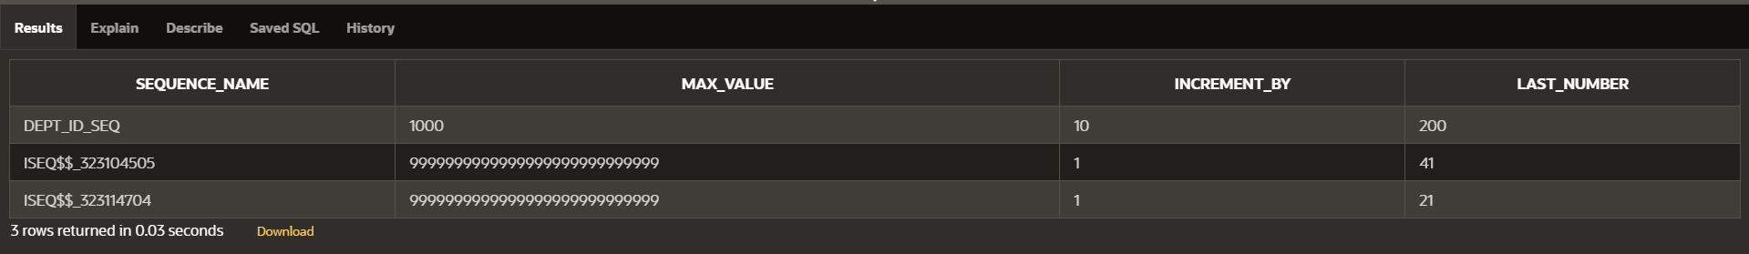

**3WriteascripttoinserttworowsintotheDEPTtable.Nameyourscriptlab12_3.sql.Besure to use the sequence that you created for the ID column. Add two departmentsnamed Education And Administration. Confirm your additions. Run the commands inyourscript.**

**INSERT INTO DEPT (DEPT_ID, DEPT_NAME)VALUES(DEPT_ID_SEQ.NEXTVAL,'Education');**

**INSERTINTODEPT(DEPT_ID,DEPT_NAME)**

**VALUES(DEPT_ID_SEQ.NEXTVAL,'Administration');**

**SELECT*FROMDEPT**

**WHEREDEPT_NAMEIN('Education','Administration');**



1. **Create a non unique index on the foreign key column (DEPARTMENT_ID) in theEMPLOYEEStable.**

**CREATE INDEX employees_department_id_idxONEMPLOYEES (DEPARTMENT_ID);**

1. **DisplaytheindexesanduniquenessthatexistinthedatadictionaryfortheEMPtable.**

**SELECT INDEX_NAME, UNIQUENESSFROMUSER_INDEXES**

**WHERETABLE_NAME='EMPLOYEES';**



|  |  |  |
| --- | --- | --- |
| **Ex.No.: 16** | | **CONTROLLING USER ACCESS** |
| **Date:** | 03/10/2024 |

1. **WhatprivilegeshouldauserbegiventologontotheOracleServer?Isthisasystemoranobjectprivilege?**

**TheprivilegeausershouldbegiventologontotheOracleServeristheCREATESESSIONprivilege.**

**Type of Privilege: This is a system privilege.GRANTCREATESESSIONTOusername;**

1. **Whatprivilegeshouldauserbegiventocreatetables?**

**theuserneedstheCREATETABLEprivilege.**

**TheCREATETABLEprivilegeallowstheusertocreatenewtablesintheirownschema.**

**GRANTCREATETABLETOusername;**

1. **Ifyoucreateatable,whocanpassalongprivilegestootherusersonyourtable?**

**When you create a table, only you as the table owner (or a user with the ADMIN OPTIONor GRANT ANY PRIVILEGE system privilege) can grant privileges on your table to otherusers.**

**GRANTSELECTONyour_tableTOother_user;**

1. **You are the DBA. You are creating many users who require the same systemprivileges.Whatshould youuse tomakeyour jobeasier?**

**AsaDBA,tosimplifytheprocessofgrantingthesamesystemprivilegestomultipleusers,you should use roles.**

**CREATEROLEmy_role;**

**GRANT CREATE SESSION TO my_role;GRANTCREATETABLE TOmy_role;**

**GRANTmy_roleTOuser1;GRANTmy_roleTOuser2;**

1. **Whatcommanddoyouusetochangeyourpassword?**

**ALTERUSERusernameIDENTIFIEDBYnew_password;**

1. **Grant another user access to your DEPARTMENTS table. Have the user grant youqueryAccess tohis orher DEPARTMENTS table.**

**Grant Accessto Your DEPARTMENTSTable**

**GRANTSELECTONyour_username.DEPARTMENTSTOother_user;**

**Grant Query Access toOtherUser's DEPARTMENTSTable**

**GRANTSELECTONother_user.DEPARTMENTSTOyour_username;**

1. **QueryalltherowsinyourDEPARTMENTStable.**

**SELECT*FROMDEPARTMENT;**

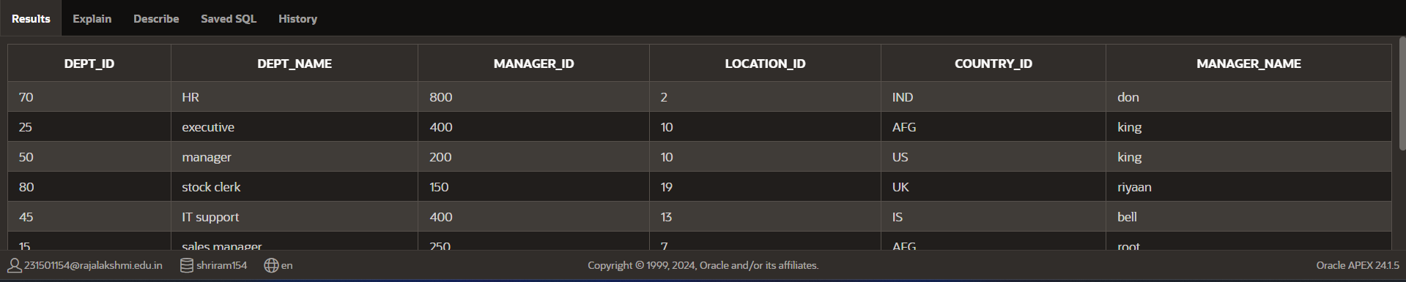

1. **Add a new row to your DEPARTMENTS table. Team 1 should add Education asdepartment number 500. Team 2 should add Human Resources department number 510.Querytheotherteam‘stable.**

**INSERTINTODEPARTMENT(dept_id,**

**DEPT_NAME,manager_id,location_id,country_id,manager_name)VALUES(500,'Education',300,12,'BAN','ball');**

**INSERTINTODEPARTMENT(dept_id,**

**DEPT_NAME,manager_id,location_id,country_id,manager_name)VALUES(510,'HumanResources',150,10,'AUS','john');**

**SELECT*FROMDEPARTMENT;**



1. **Query the USER_TABLES data dictionary to see information about the tables that youown.**

**SELECT*FROMUSER_TABLES;**

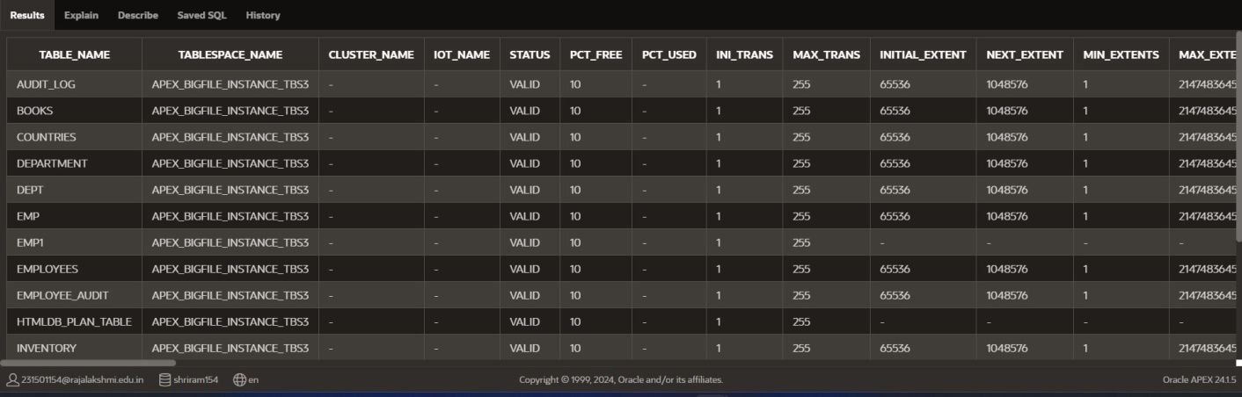

1. **RevoketheSELECTprivilegeonyourtablefromtheotherteam.**

**REVOKESELECTONteam1_user.DEPARTMENTSFROMother_user;**

1. **Remove the row you inserted into the DEPARTMENTS table in step 8 and save thechanges.**

**DELETE FROM DEPARTMENTWHEREDEPT_IDIN(500,510);**